Door Finger Guard Guidance
This guidance is predominantly considering schools; however it is also applicable to all public buildings for which young children will have access to areas & facilities.
Unprotected hinge side of doors can effectively act as a guillotine to fingers being trapped between the door and the door jamb/frame. The types of injuries range from crushing, bruising and fractures to, in the most serious cases, amputation. However, whatever the outcome, every finger trapping incident is likely to cause pain and distress to a child.
In terms of preventing finger trapping injuries from the hinge side of doors, finger guarding devices are widely available, relatively low-cost items that do not necessarily require specialist fitting.
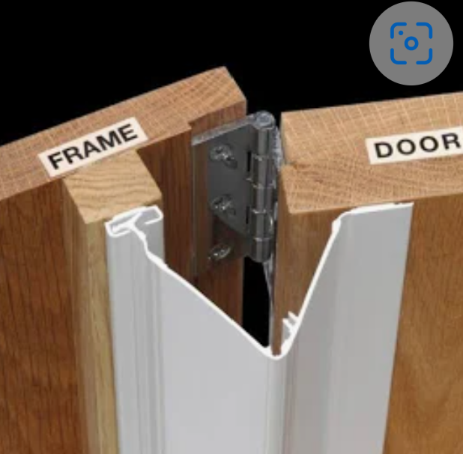
It is strongly advised fitting these in areas where there is a potential risk of finger entrapment. These areas can be identified by using the risk assessment approach below.
Whilst all doors are potentially a risk to children, classroom doors, toilet entrance doors and toilet cubicle doors represent the highest risk of finger trapping accidents.
Risk Assessment Approach
A visual inspection of each internal and external door should be carried out to determine the degree of risk and whether further action is required to eliminate or reduce that risk. It can be helpful to observe pupil activity during the inspection.
Factors to be considered
- Consider the age group and other characteristics such as special educational needs, behaviour and disabilities of children in determining the level of risk.
- Consider areas where children are not supervised e.g. toilets and where pranks by children could occur.
- Think about circulation routes and queuing areas such as the dining hall.
- Review your premise accident records to establish any doors that may have been involved in previous finger trapping incidents or near misses.
Particular attention should be paid to the following:
Door design;
- Heavy doors (with or without dampening mechanisms).
- Fire doors with self-closing mechanisms.
- Design of doors e.g. metal and timber doors without rounded edges.
- Check that all doors already fitted with self-closures have a two-stage closing action i.e. rapid initial and then slow final close and are regularly maintained.
Location of the door;
- Doors next to areas where pupils congregate.
- Doors which pupils queue beside for lunch or other reasons.
- Doors near entrances.
- Doors that are susceptible to slamming from strong gusts of wind.
- Areas used by after-school clubs or community use, particularly if these involve younger children.
- Is there a notice board or some other attraction behind or adjacent to the door?
- Changes to layout of rooms including toilets, which may introduce new hazards.
Determining the risk
Having identified the risks during the inspection, each door should be given a risk rating of either high, medium or low. The judgment should take into account the age group of the children exposed to the risk and any special educational needs, the likelihood of harm occurring and the potential severity should that harm be realised.
Risk control measures
The following measures should be considered to help prevent finger trapping incidents:
- Try to reduce or remove the need for pupils to gather near the doors.
- Ensure that essential equipment is not positioned adjacent to or immediately behind doors e.g. a paper towel dispenser.
- Give regular briefings to pupils on the dangers of finger trapping.
- Ensure that all staff aware of the hazard of door entrapments and their role in being vigilant and reporting defects and near miss incidents.
- Fit finger safety devices on doors that pose a risk.
- Consider risk factors when replacing or refurbishing doors.
As with any safety device, it is important that there are regular checks and inspections in place to ensure they remain fixed in position and are not damaged. A record of checks together with actions taken should be maintained.
Property Services Group will be able to offer advice on appropriate guards. There are various types available that range in price.
Door Finger Entrapment Assessment (Risk of crush or amputation)
Premise Name:
Date of assessment:
Door No. | Door Location Name / Description | Age group or characteristic | Door design & Characteristics | Busy or congested area | Minimal supervision of area | Risk Rating  H / M / L | Finger Guard Fitted  Y / N | Notes / Comments
1
2
3
4
5
6
7
8
9
10
11
12
13
14

