COSHH RISK ASSESSMENT 

Establishment |  |  |  | Reference No.
Substance Used (Description)
(N.B. quantities, concentrations on back of sheet)

Work Activity (cleaning, experiment, crafts etc)

Persons At Risk (employees, pupils, visitors, public, service user) |  | (Persons with specific allergies e.g. asthma, sensitised by latex etc)
Safety Precautions |  |  | Personal Protective Equipment |  |  | Yes/No
 |  |  | Goggles
 |  |  | Gloves
 |  |  | Face Shield
 |  |  | Other e.g. respirator, dust mask, apron etc.
Spillage Procedure

Hazards and First Aid

Area | Symptoms of Exposure | Treatment
Skin

Eyes

Ingestion

Inhalation

SUBSTANCE |  |  |  |  |  |  | SUPPLIER |  |  |  |  |  |  |  |  |  |  |  |  |  |  | Ref No
 |  |  |  |  |  |  |  |  |  |  |  |  |  |  |  |  |  |  |  |  |  | Are Hazard Data sheets available
TRADE NAME |  |  |  |  |  |  | TEL NO |  |  |  |  |  |  |  |  |  |  |  |  |  |  | WORK EXPOSURE LIMIT  (WEL)
HAZARD |  |  | IRRITANT |  |  |  |  |  |  | CORROSIVE |  |  |  |  |  |  |  | SERIOUS Human Health Hazard |  |  |  |  |  |  |  |  |  | TOXIC/ACUTE TOXICITY
WARNINGS  (Tick) |  |  | 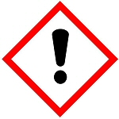 |  |  |  |  |  |  | 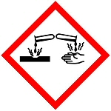 |  |  |  |  |  |  |  |  |  |  |  |  |  |  |  |  |  | 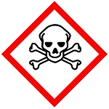
EXPLOSIVE |  |  | FLAMMABLE |  |  |  |  |  |  | OXIDISING |  |  |  |  |  |  |  | GAS UNDER PRESSURE |  |  |  |  |  |  |  |  | ENVIRONMENT
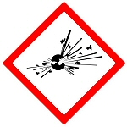 |  |  | 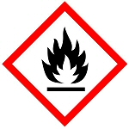 |  |  |  |  |  |  | 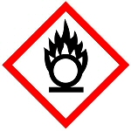 |  |  |  |  |  |  |  |  |  |  |  |  |  |  |  |  | 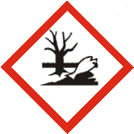
LIKELY ROUTE OF ENTRY TO THE BODY (tick)
INHALATION |  |  |  | INGESTION |  |  |  |  |  |  |  |  |  | ABSORPTION |  |  |  |  |  |  |  |  |  | INJECTION
nil | slight | mod | high | nil |  | slight |  |  |  | mod | high |  |  | nil |  | slight |  |  |  | mod | high |  |  | nil |  | slight |  |  |  | mod | High
STORAGE |  |  | LOCATION |  |  |  |  | QUANTITY |  |  |  |  |  |  | SOLID |  |  |  |  |  |  |  | CHEMICAL CONSTITUENTS
 |  |  |  |  |  |  |  |  |  |  |  |  |  |  | LIQUID
 |  |  |  |  |  |  |  |  |  |  |  |  |  |  | GAS
USE  (cleaning, experiment,  craft) |  |  | QUANTITY USED (grams, kg, mls, litres) Total per session, task etc. |  |  |  |  |  |  |  |  |  |  |  |  |  | METHOD OF APPLICATION (concentrated, diluted,  temperature)
 |  |  | FREQUENCY/ DURATION OF USE |  |  |  |  |  |  |  |  |  |  |  |  |  | PRODUCT FORMED  (solid, liquid, gas, dust, vapour, fumes etc)
RISK CONTROL  (engineering controls e.g. LEV, fume cupboard, general ventilation, other) |  |  |  |  |  |  |  |  |  |  |  | PERSONAL PROTECTIVE EQUIPMENT USED  face/eyes – visor, goggles, spectacles/ hands – respiratory (RPE)
DISPOSAL  Autoclave/Yellow bags  Foul water drain  Chemical waste  No hazard |  |  | PRODUCTS
ACCIDENTAL RELEASE (Spillage) |  |  | METHOD – (Neutralise/dilute)
ASSESSOR

ASSESSMENT DATE

REVIEW DATE

