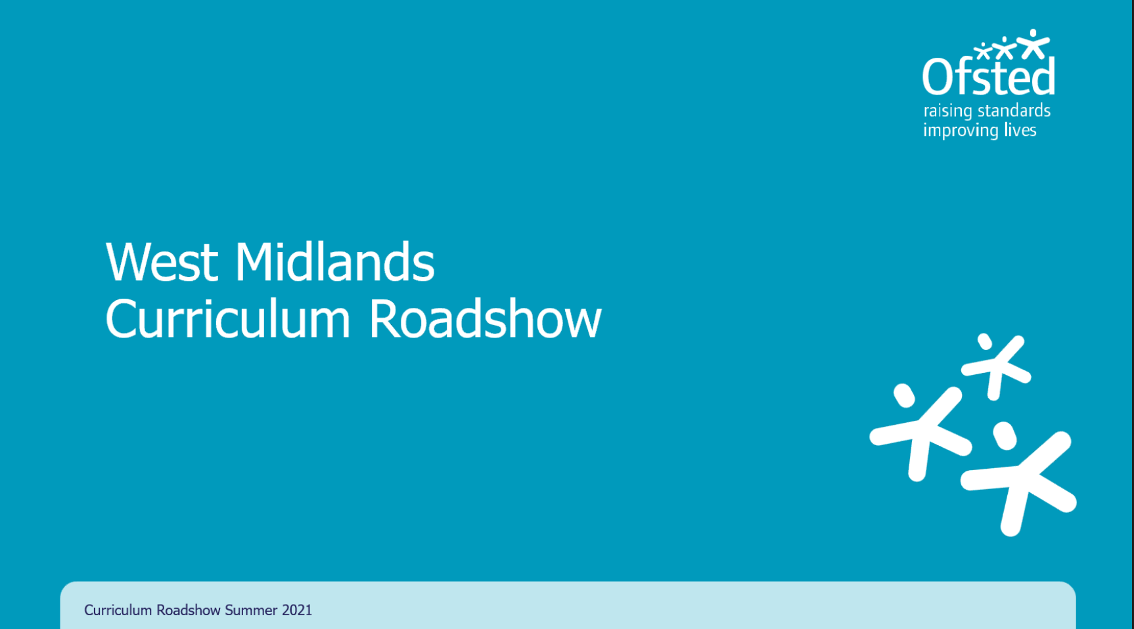
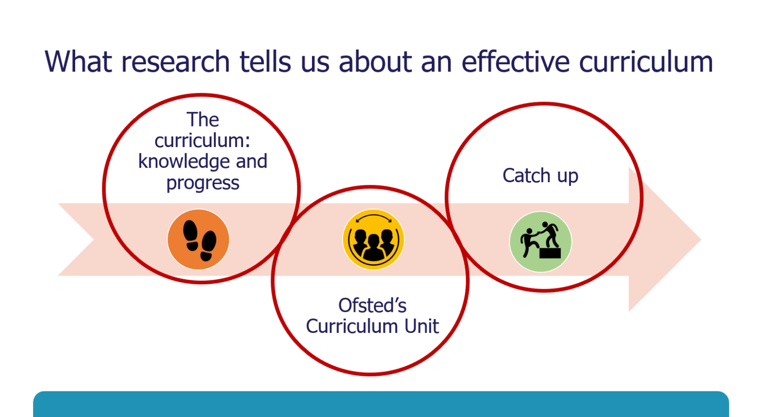 |  | Jonathan Keay
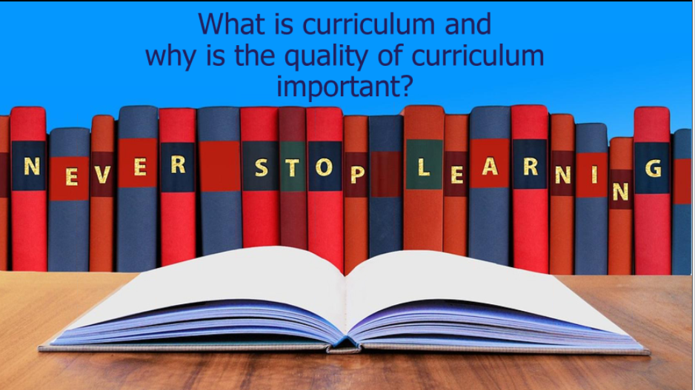 |  | Focus on the ‘what is taught’.  And then consider the ‘how’ (pedagogy)  Need not to position the ‘how’ first.
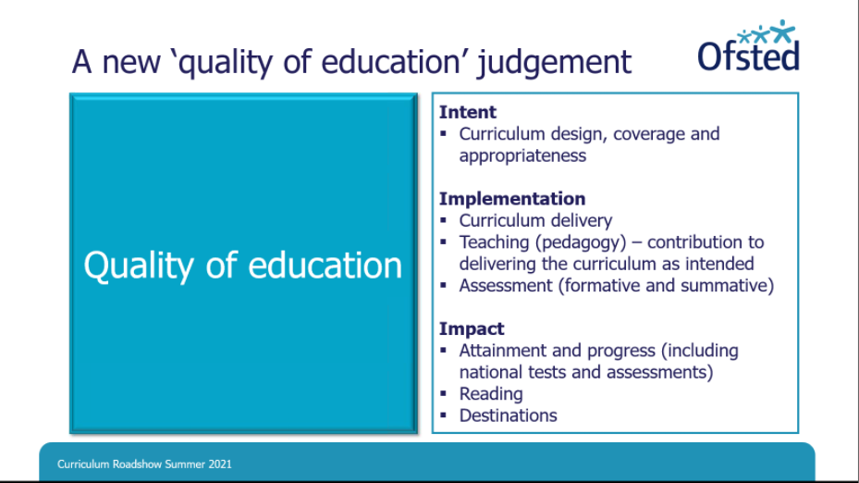 |  | Ofsted went further with definition of curriculum
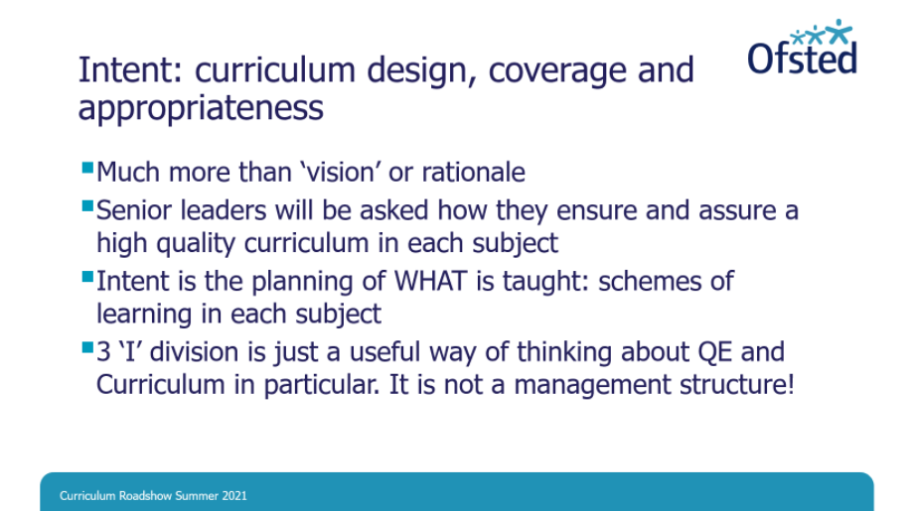
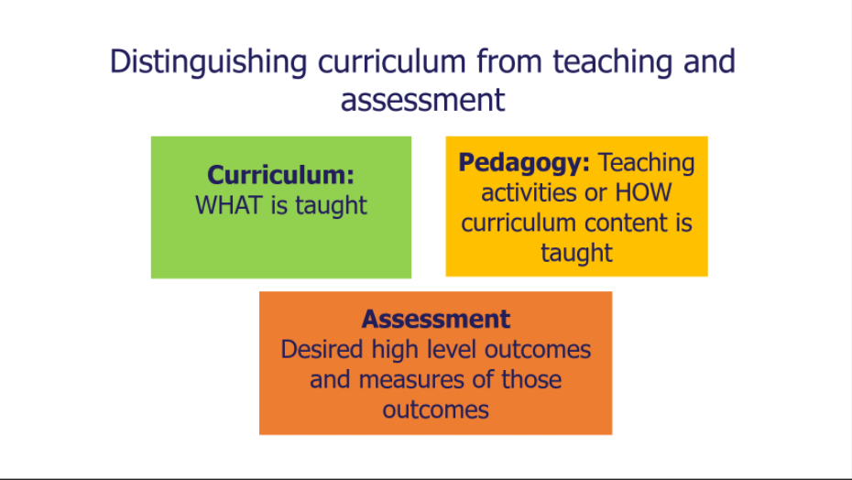 |  | Need to distinguish between curriculum, pedagogy and assessment.  Lure of activity, may have been promoted to timetable without consideration of why it is there or how it builds on prior learning.  Not to say that learning can’t be engaging.  But the ‘what’ needs to come first.
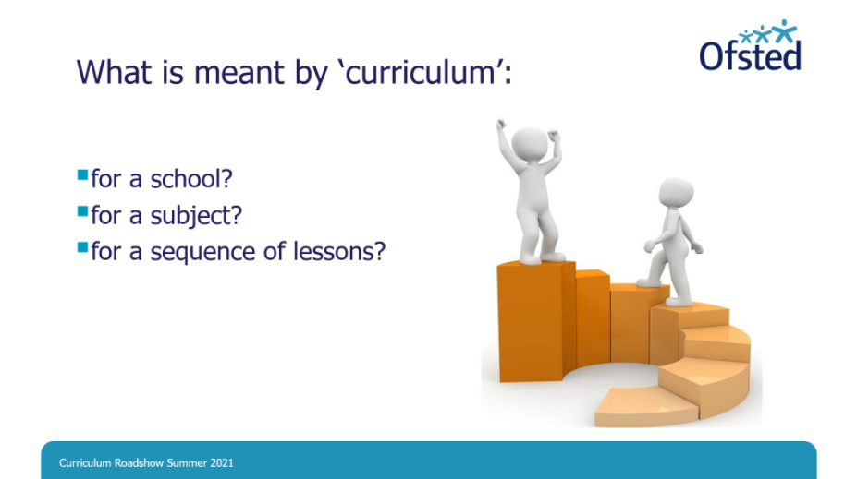 |  | Curriculum is substance of what is taught  Curriculum therefore at heart of quality of education judgement  No need to create anything new or design things from scratch.  EYFS and NC can carry much of the load.  Primary that fulfils the letter and spirit of NC is already in the right place.
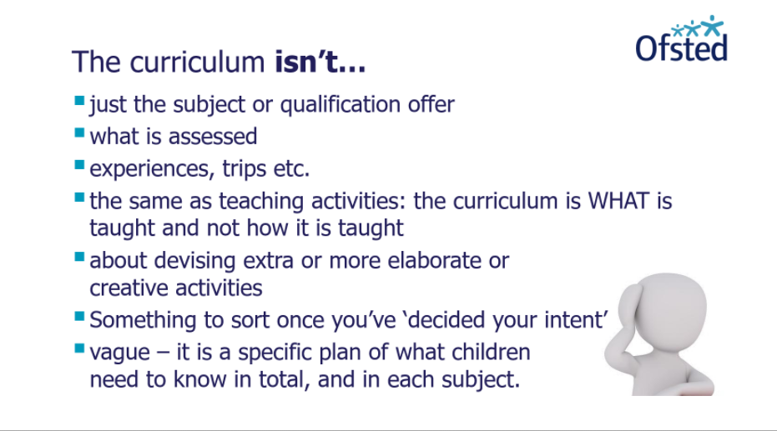 |  | Curriculum isn’t something which takes away from the ‘what’ (intent)
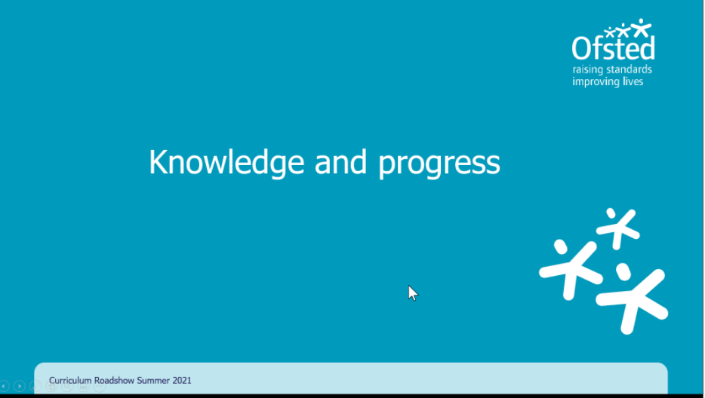
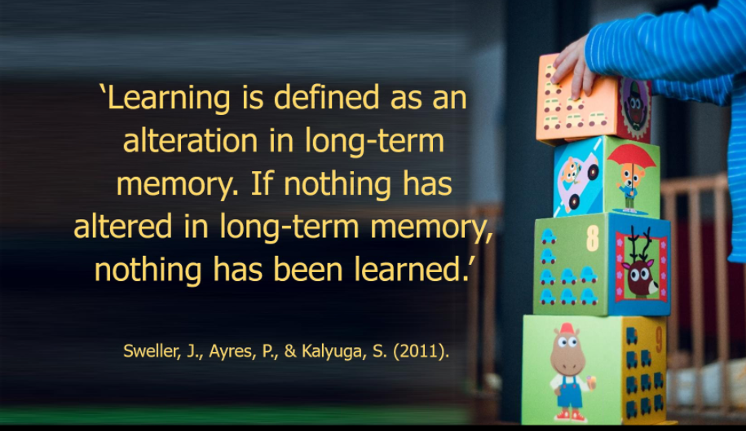 |  | Progress is ‘knowing more and rembering more, but forgetting happens’
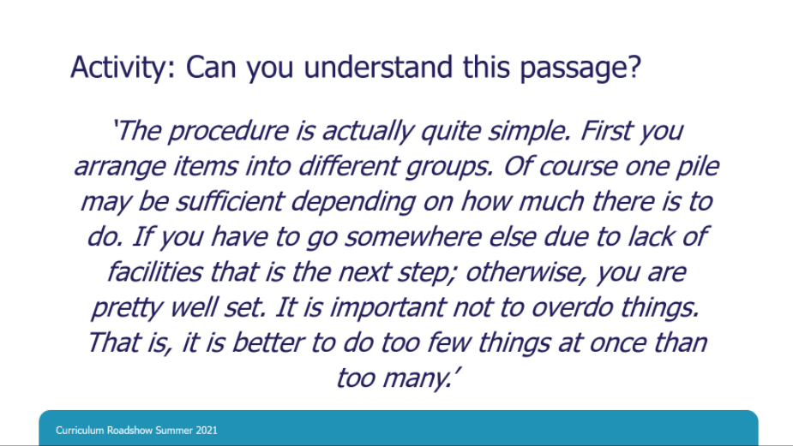 |  | If we don’t learn and remember, we can’t comprehend.  Quite hard to understand what’s going on.
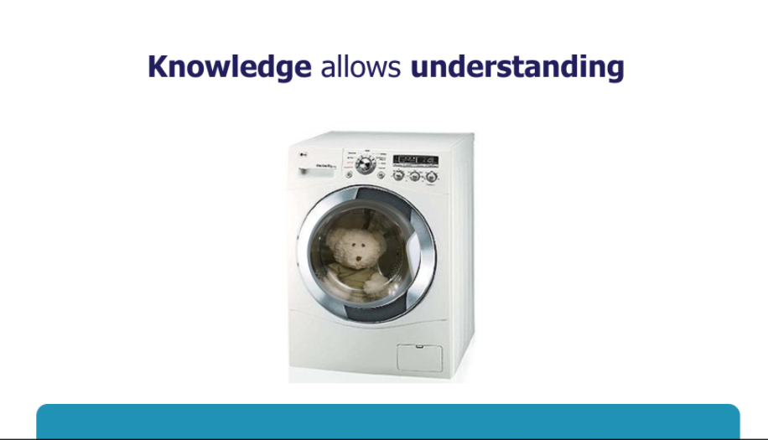
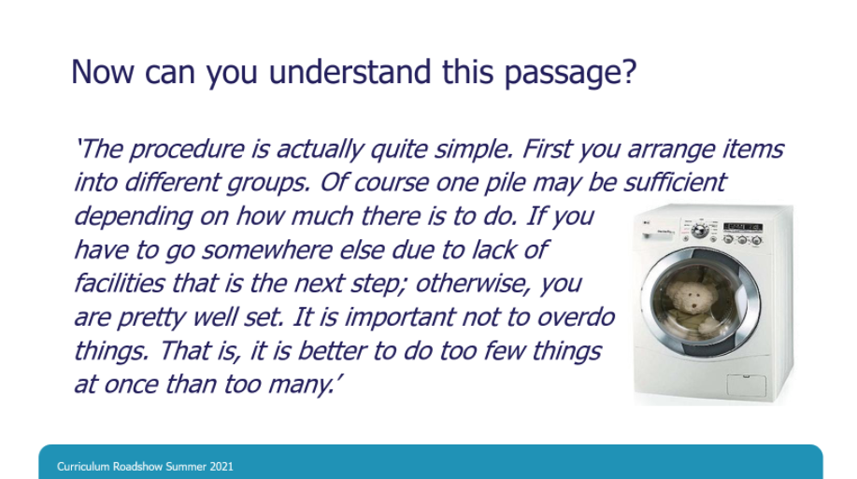 |  | What we know, allows us to undertsnating what we know, hear and experience.  Meaning is often inferred
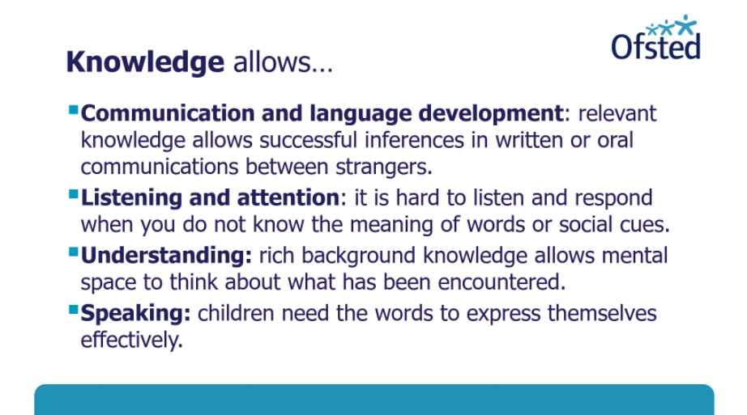 |  | Prior knowledge is key,  If you don’t know the meaning of words, social cues, it’s hard to join in.
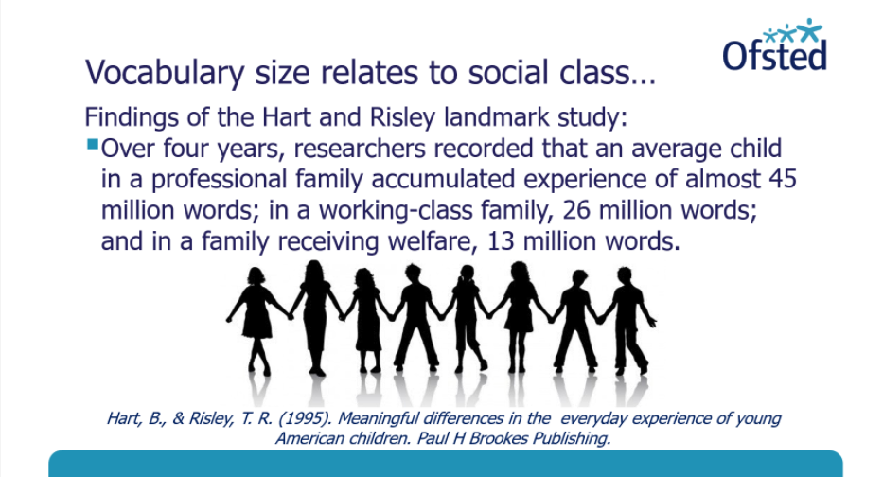 |  | Words we know, affects how successful we are.
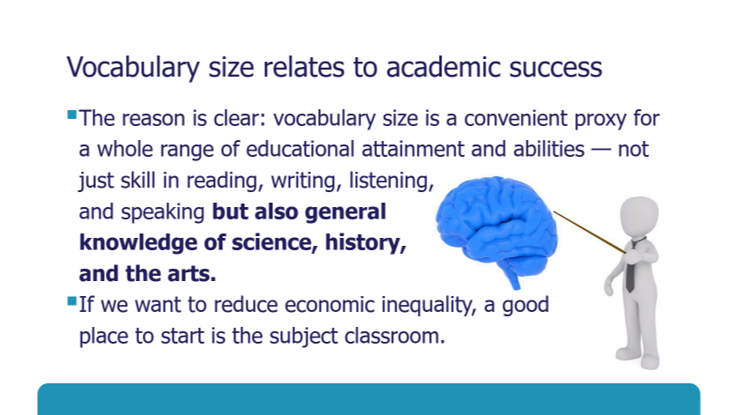 |  | Knowledge across curriculum is key
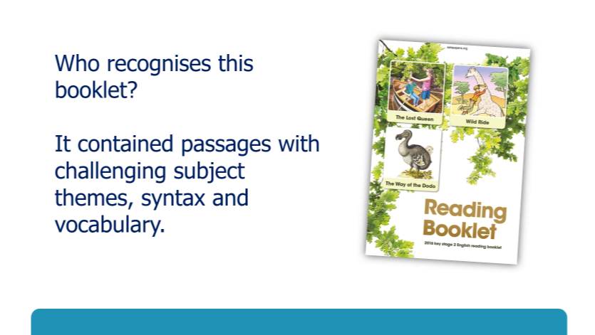 |  | 2016 SAT paper  Many schools found it hard because it boiled down to what children did and didn’t know.  Spanned a breadth of the NC  Knowledge gaps affected pupils ability to make progress.
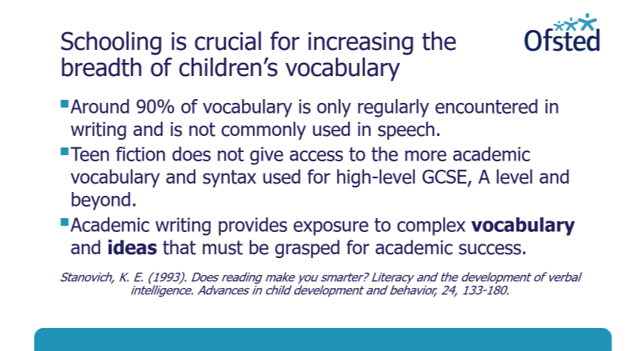 |  | Many pupils wouldn’t know the meaning of words without a well=-thought out curriculum
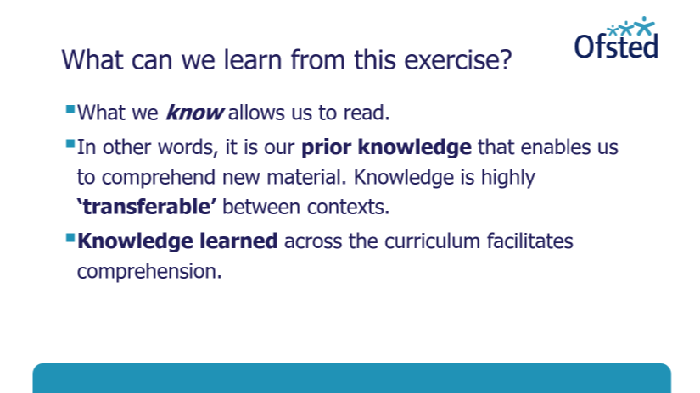 |  | Poor readers outperform good readers when they know about the topic.
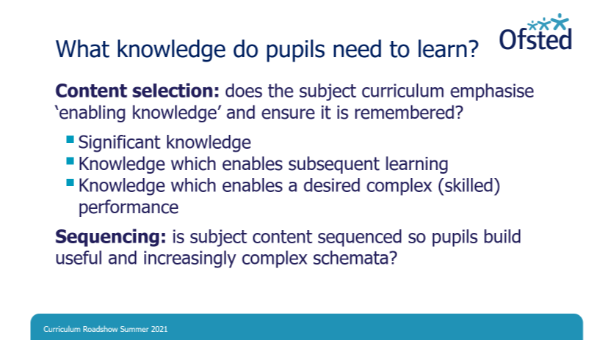 |  | Significant knowledge e.g.Pyramids  Something which everyone should learn about.  But whatever is taught, needs to be sequenced.
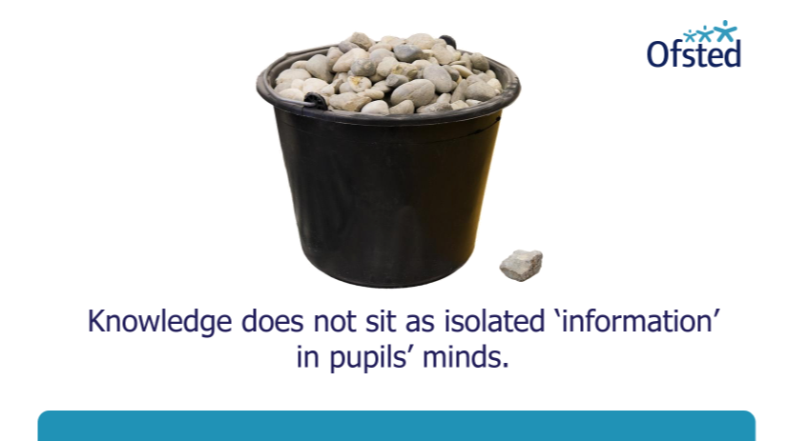
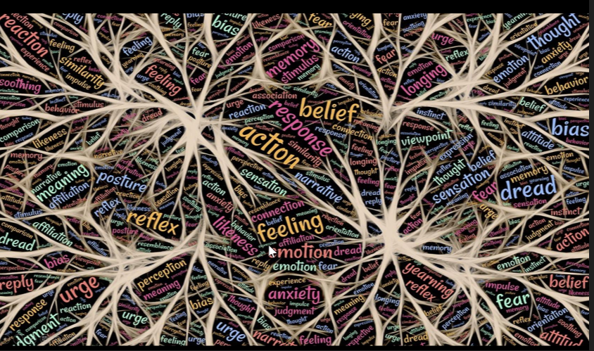 |  | Schemata  ‘Democracy’ and ‘republic’ concepts etc. enable children to connect to prior learning and make connections each time they experience it.  KNowdlges grows when connecte to that know.
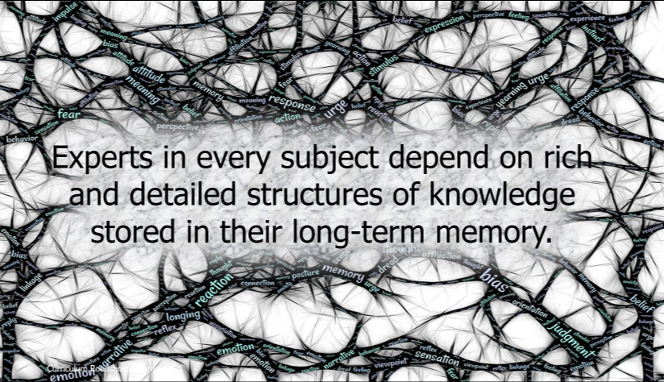 |  | The more you know, the deeper the understanding.  Experts learn things readily into schema
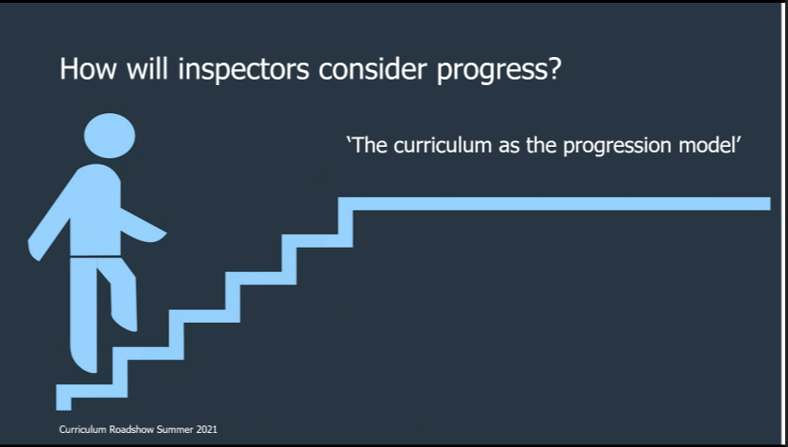 |  | Progress is when children learn that which was intended
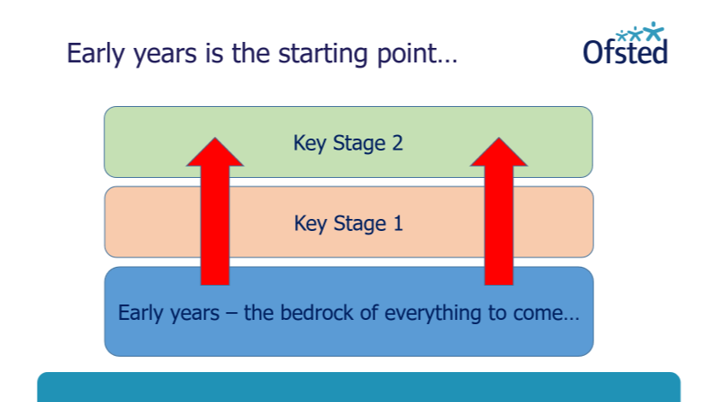 |  | Two key features of progression model (from beginning to end)  EY is the start of the progression model.  Need to start with the EY
V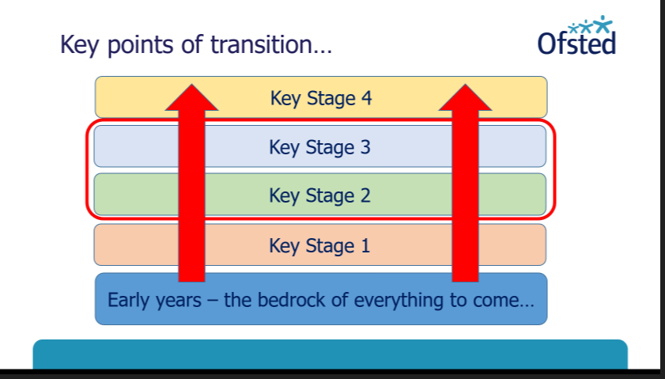 |  | Transition  Each phase causes readiness for what comes next  Effective providers liaise and find out as much as possible about what’s coming next
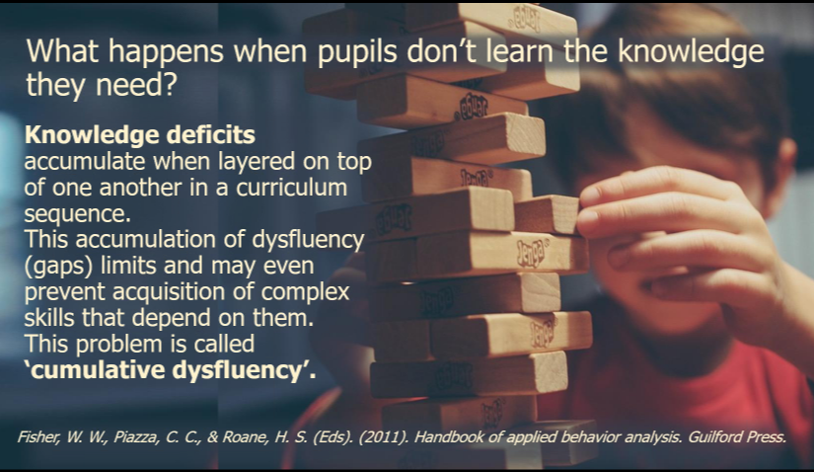 |  | Gaps make future learning harder.
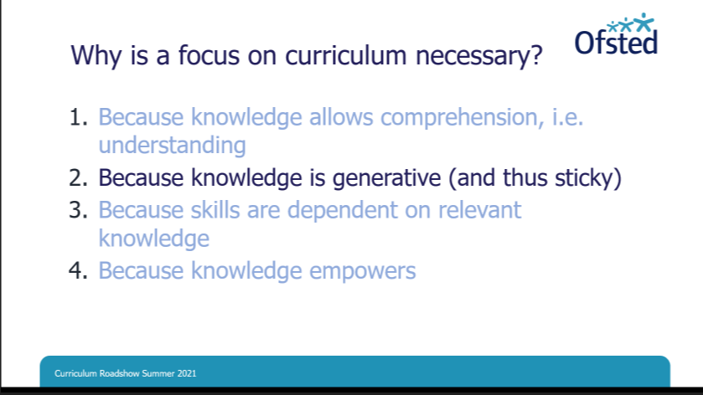
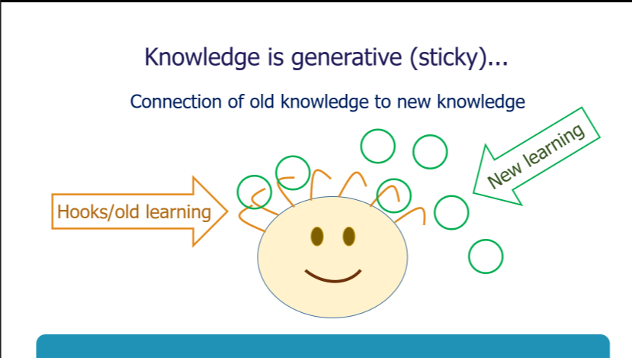 |  | The more you know, the greatger the capacity for knowledge
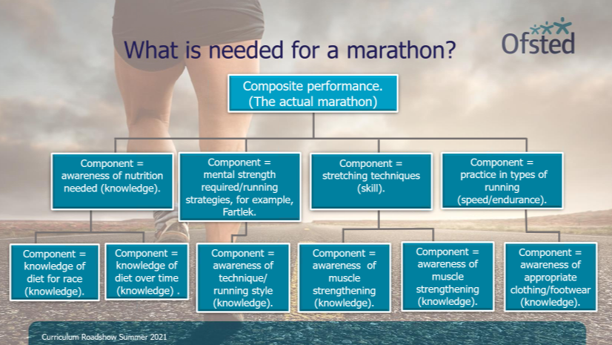 |  | 3  Can sometimes make mistakes to complete composite tasks without the components
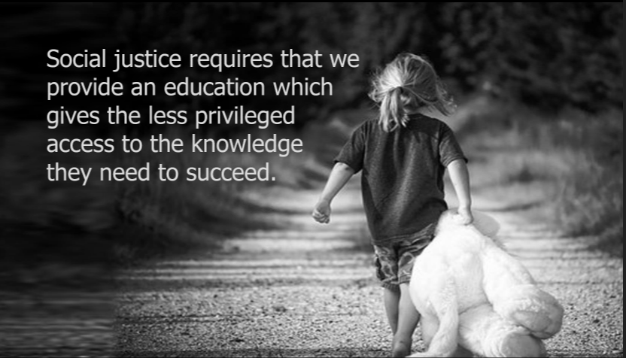 |  | Least privilendged are diostabvantaged if they don’t pick up knowdlged of others
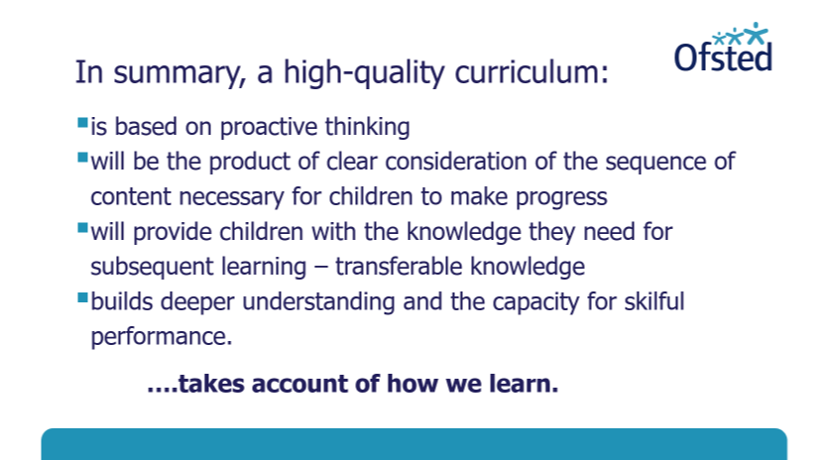 |  | Schools should have flexibility in content and structure
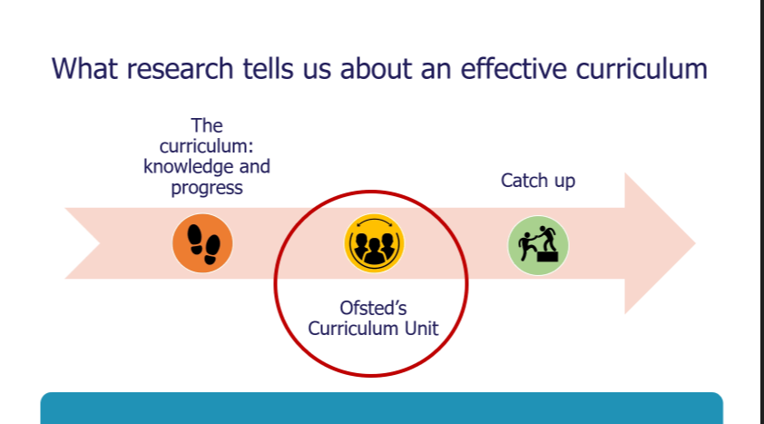 |  | Session 2
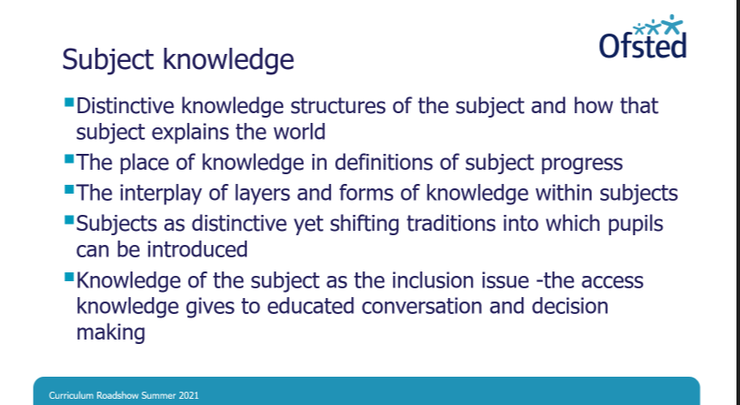 |  | Subject knowledge matters  Subjects are disciplines in their own right with own knowledge structures
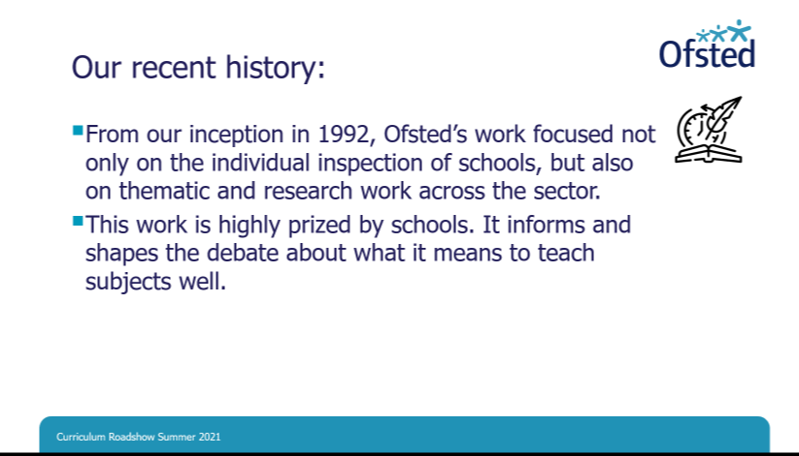
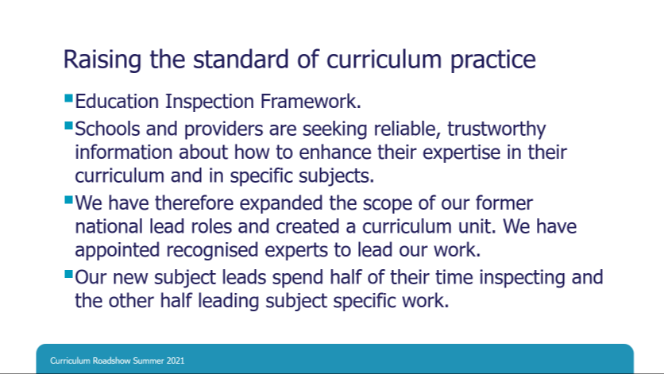
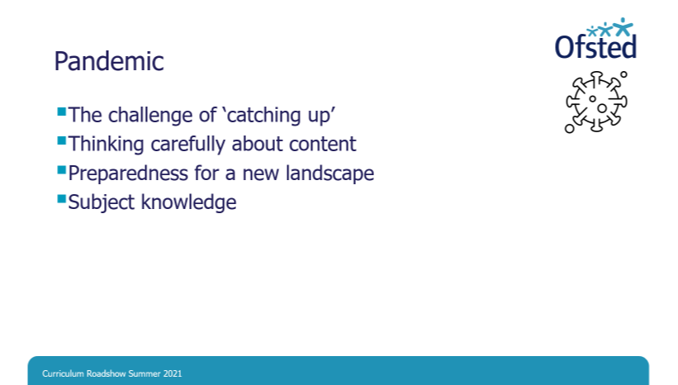 |  | What content needs to be limited, prioritised etc.
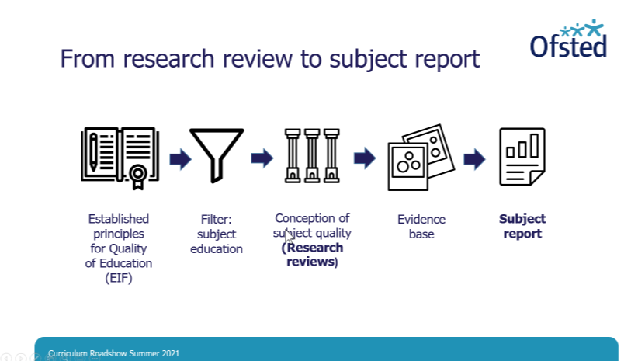
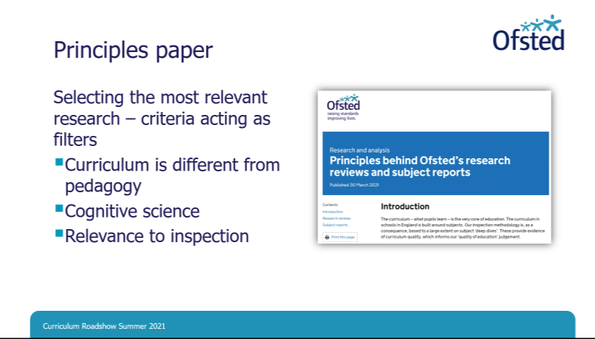
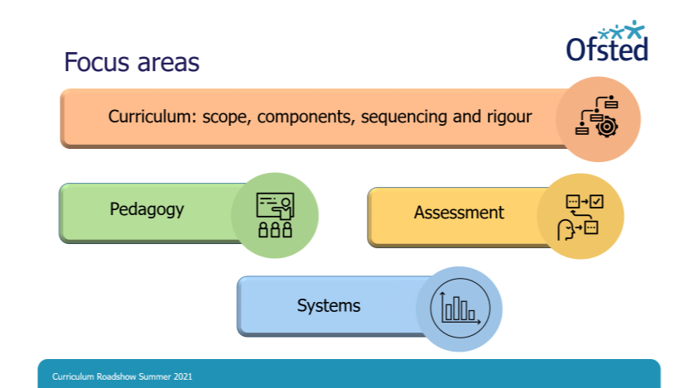
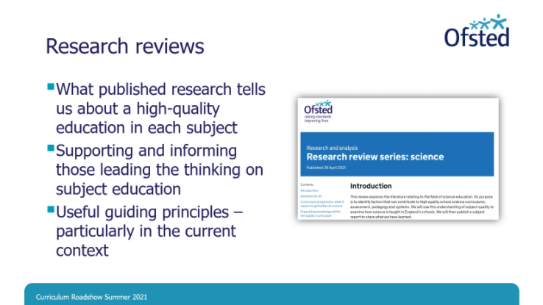 |  | Reviews structured for all audiences (specialists and non-specialists)  Series of videos explained the reviews on Ofsted social media channels  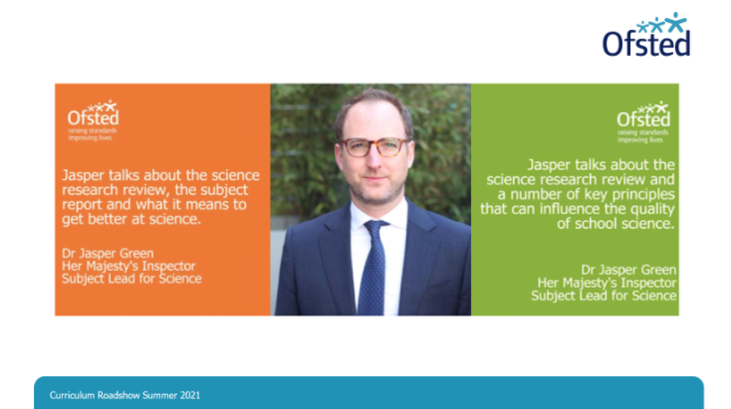
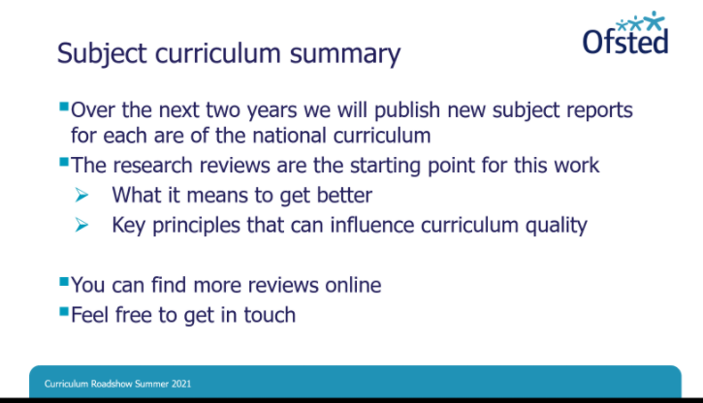
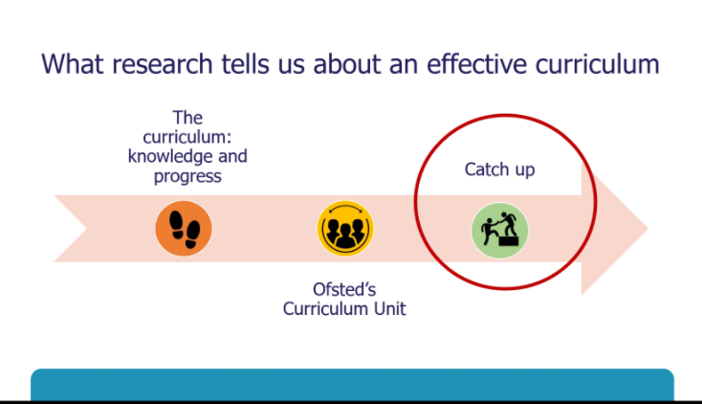
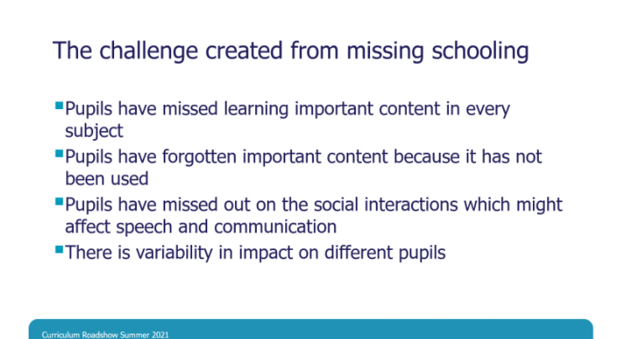 |  | What is it that’s being covered where extra time is used?
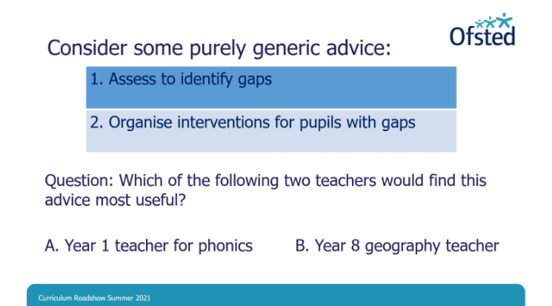
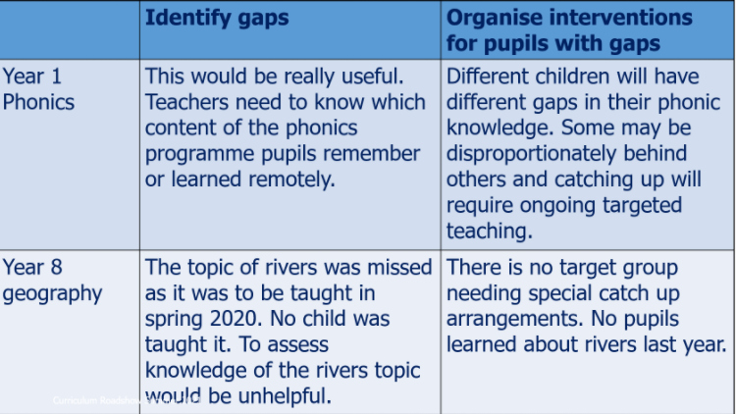 |  | For phonics, makes sense. Less sense for geography
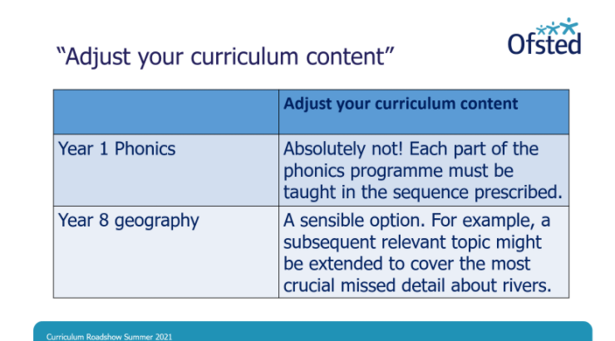 |  | For geog, next topic could be extended to cover missed content.
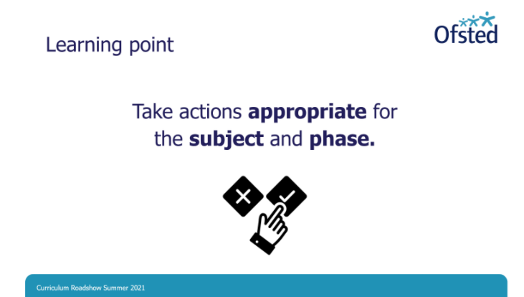
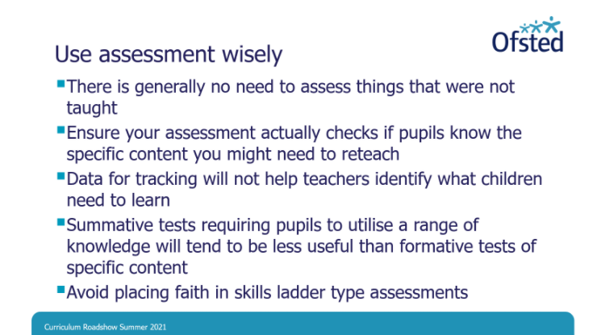 | Focus on assessment which targets components in precise ways.  What are the precise gaps?  Formative assessment is more powerful
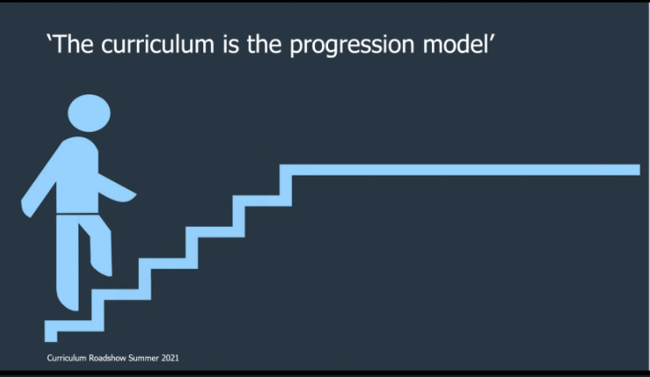 | If children are learning the curriculum, they are making progress
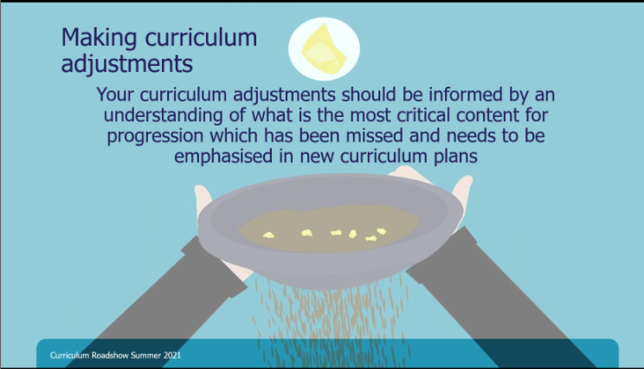 | What are the most precious, useful aspects for future progression?  In some subjects, knowledge build hierarchical (maths phonics() where assess, gap fill will work  Othes not
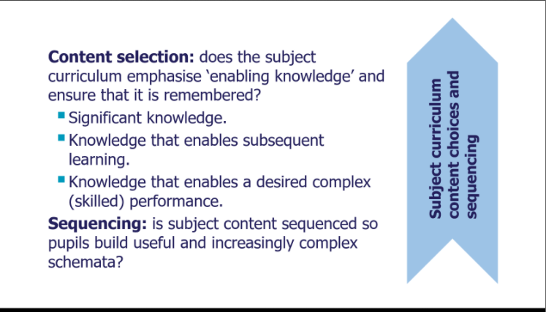
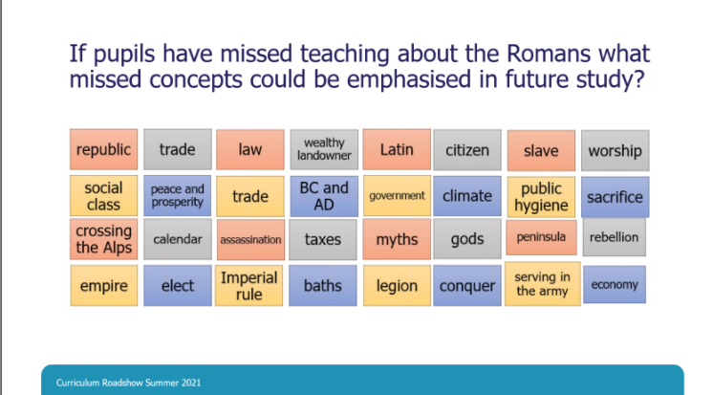 | Concepts may be missing which may be picked up elsewhere  ID concepts for subsequent learning and may return to specific elements.
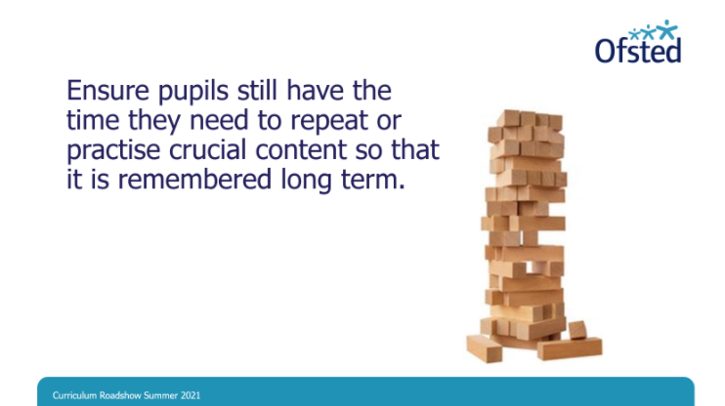
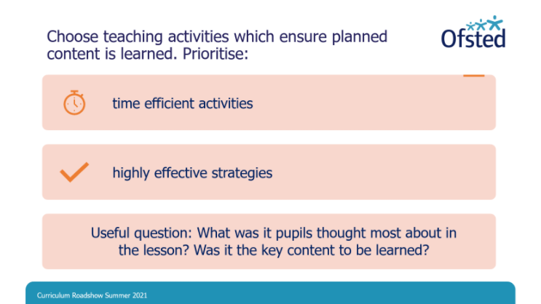
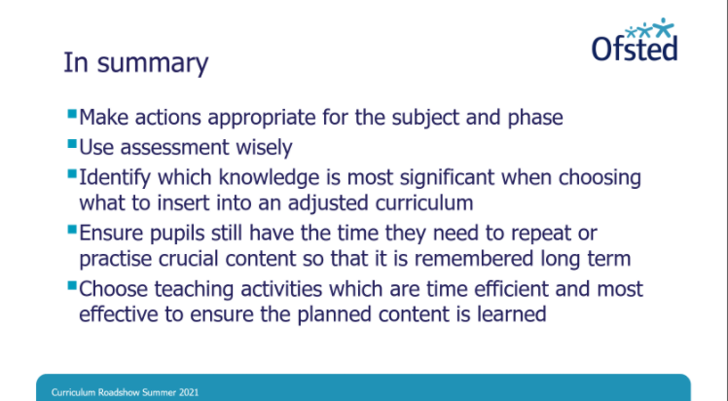
 | Ofsted doesn’t expect language used by subject leads to be replicated schools.
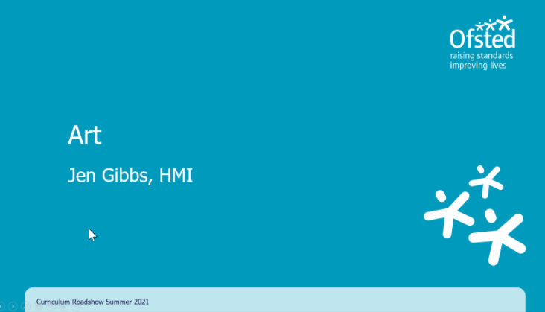
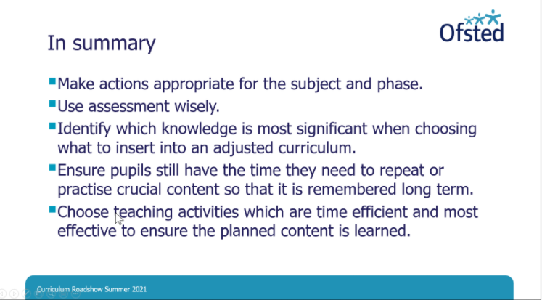
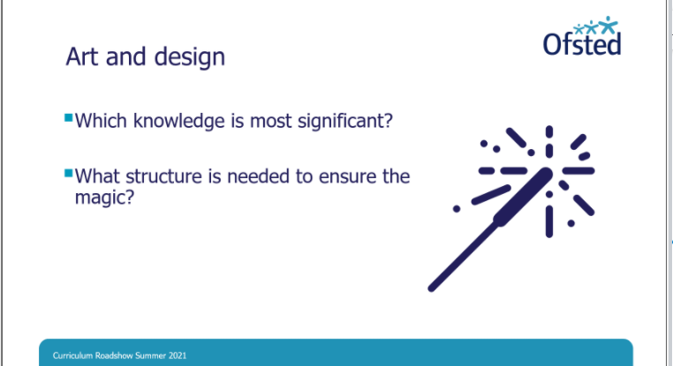
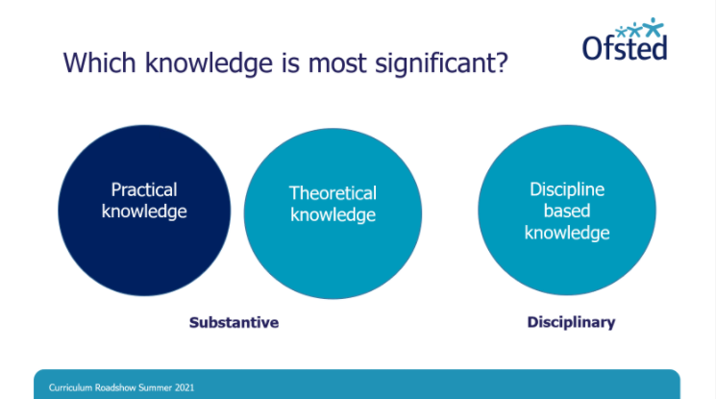 | Likely that practical knowledge should tb priortised.D
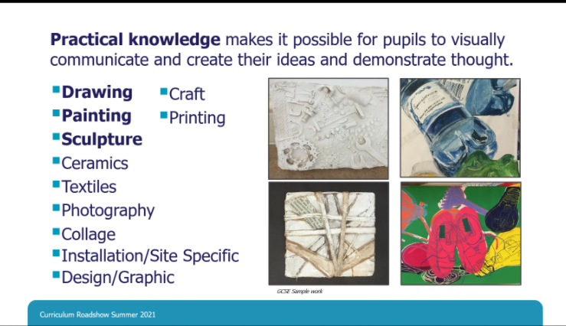 | Drawing, painting, sculpture from NC  But could break it down further
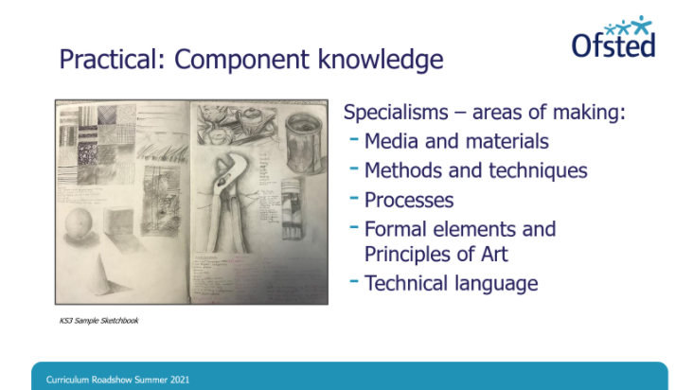 | NC Talks about end goals, but doesn’t specift what must be taught,  Schools have a lot of autonomy, but need to be specific to enable chn to gain proficiency.
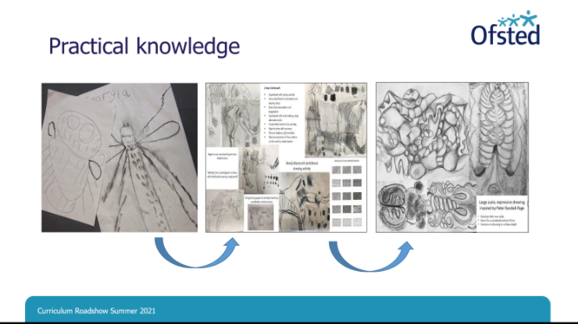 | Drawing from EY to KS2  To get to mastery we need to build knowledge and skills over time.  What do chn need to learn at each stage and how does this prepare them for what is to come.  E.g. EY – chn need level of control (fine and gross motor skills)  NC specifies ‘Range of techniques in KS1’  Will be adapting teaching and use of Formative assessment  ‘Proficiency’ at KS2 – making sure that teaching provides ops for practise with assessment and feedback to provide support where component knowledge needs refining.  Important in recovery, to consider
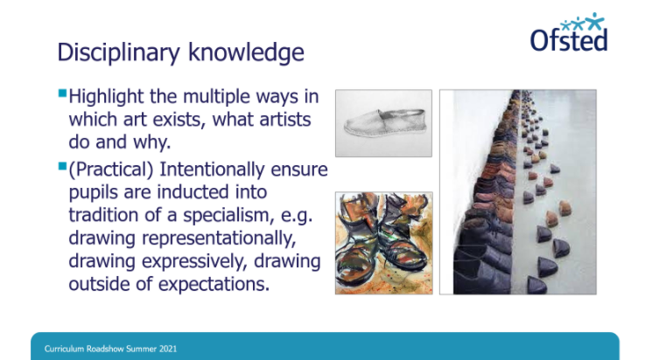 | Don’t want to teach by rote, but time is of the essence.  Consider examining other aspects to extend knowledge
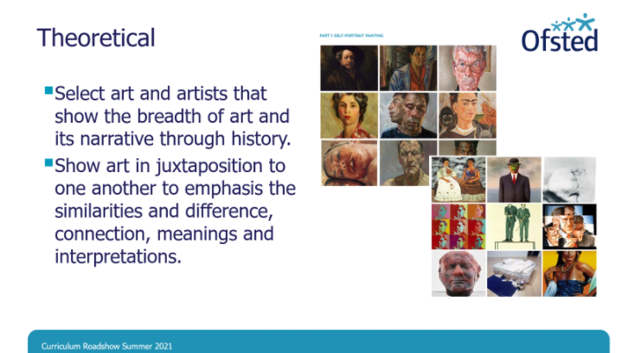 | Might be useful to compare to look at addressing where gaps might have existed.
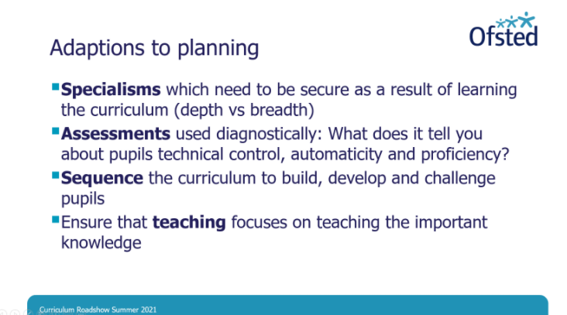 | Need to make decisions about what is to be learnt.  Use assessment to diagnose – what did we intend children to learn? Are children getting more proficient?  Children have ops to revisit components
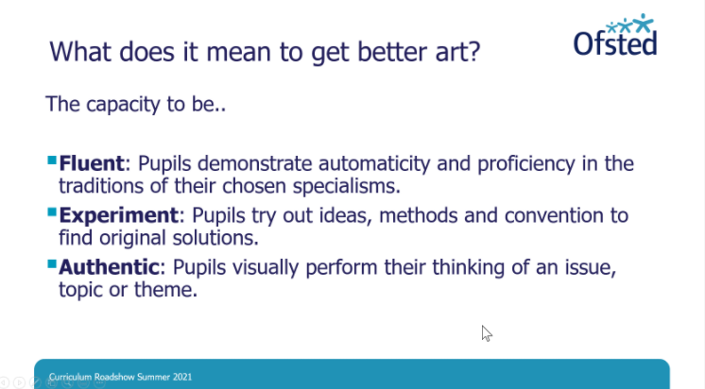 | Being “good at art” is having capacity to do a variety of different things.
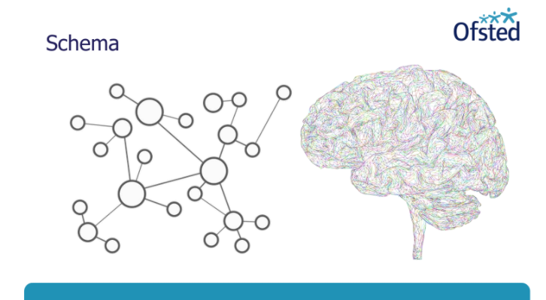 | Component knowledge builds over time  “Creativity” is about children knowing. Need to secure component knowledge to enable them to do so.
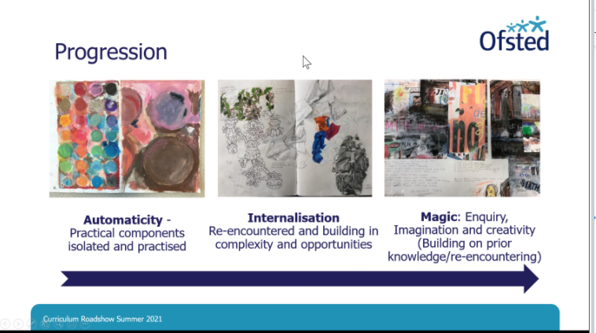 | Progression is applied to whole curriculum or could happen within a topic or a lesson.
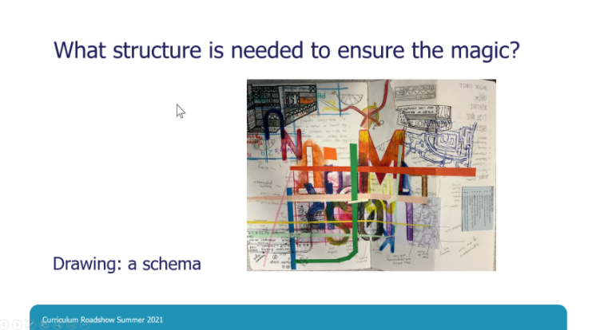 | How do you develop a schema for drawing?
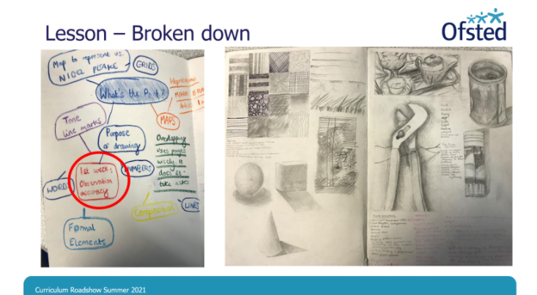 | - Sketchbook – mindmap  - Observational  - Tone  - 3D shapes  Breaking down content  Ensuring knowledge is secure and building on it.
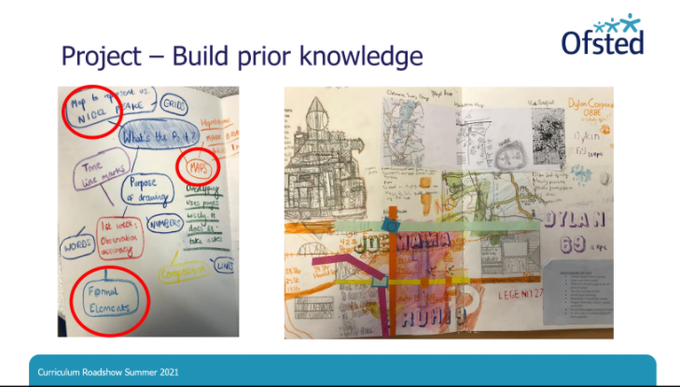 | - Building on work of known artist (prior knowledge)
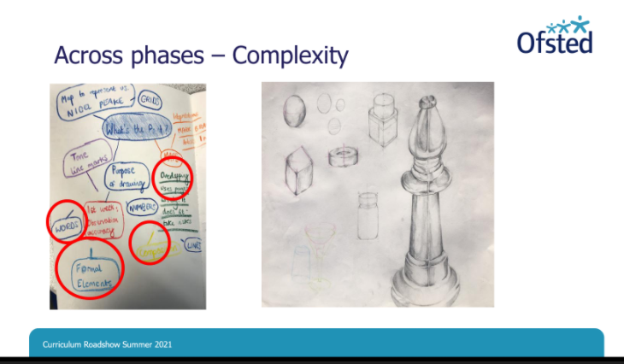 | - Formal elements developed and practised and build on  - And applied in different context and in different media  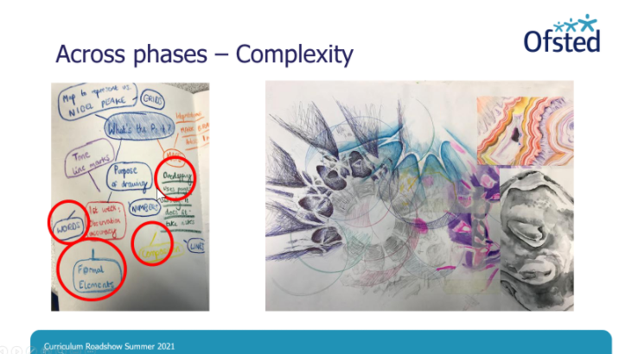
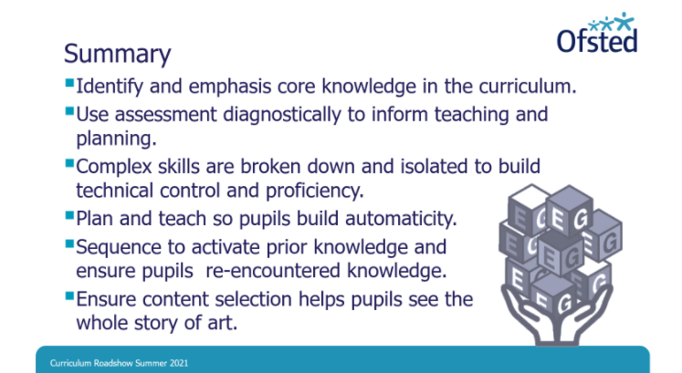 | Children need to practise to gain control and become proficient.
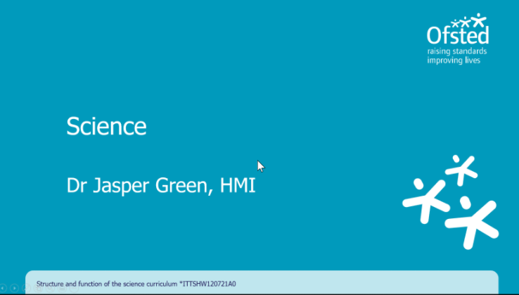
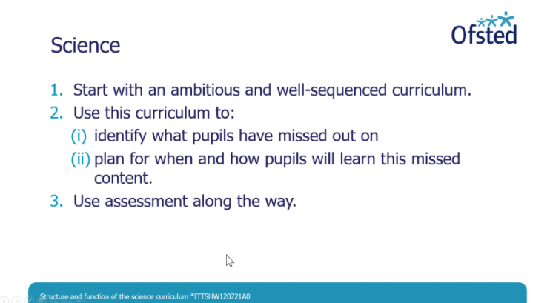
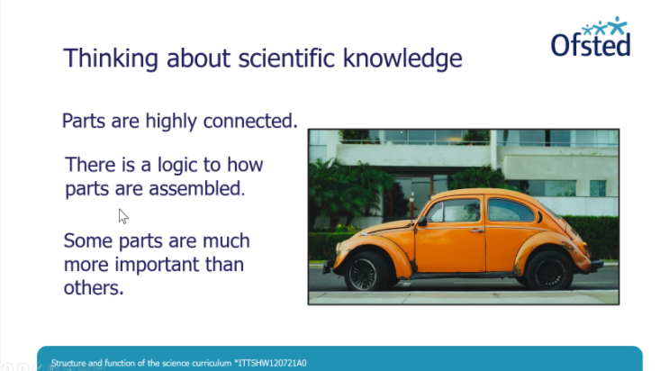 | Features of knowledge informs planning
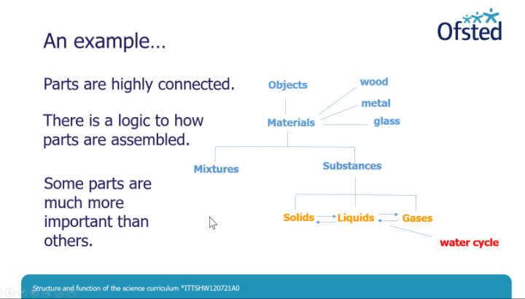 | Water cycle isn’t foundational. Knowledge of substances is. This can inform planning.
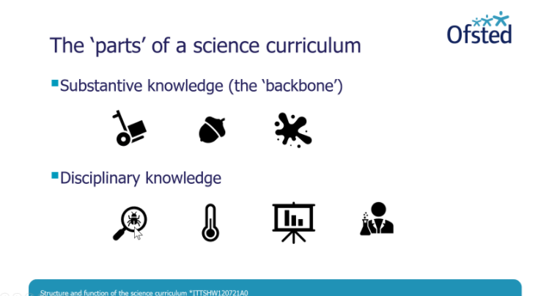 | Displing  - Methods  - Apparatus and techniques  - Data dn coMMUNITVATION  - Evidence a
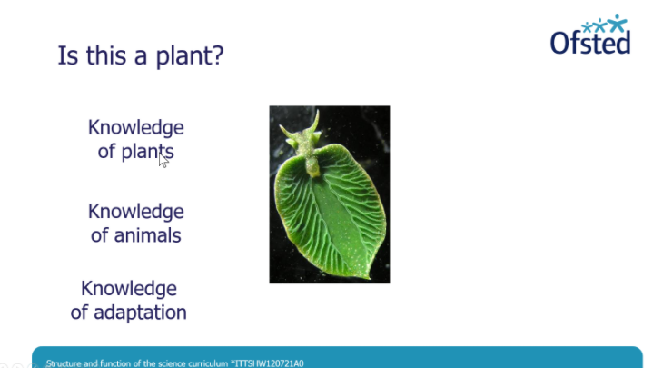 | Needs knowledge  But not enough on their own. CLassificaution (displainry knowledge) is needed)  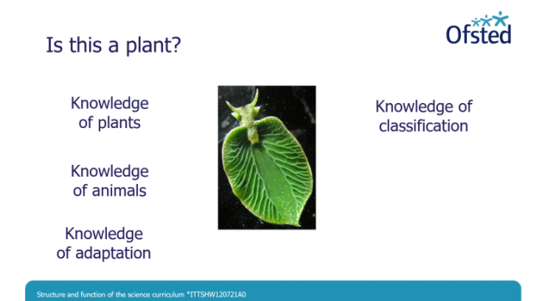  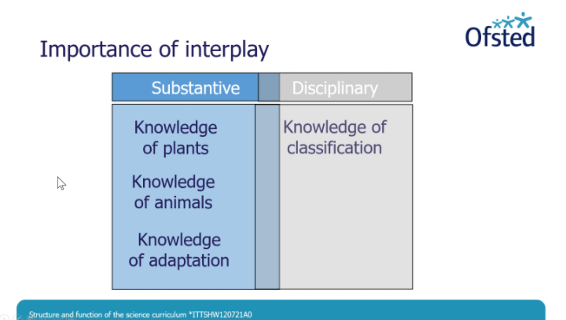
Disciplinary knowledge needs rooting in substantive context and needs teaching together
High quality curriculum plans how both knowledge progress together,
 | 2.
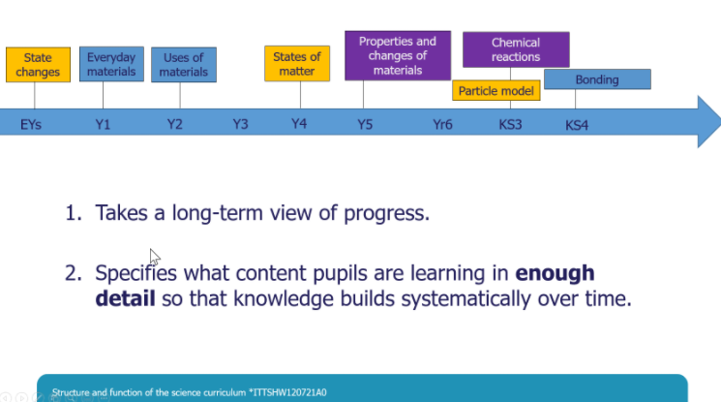 | Knowledge being disciplinary and substantive  What materials in Y1?  What uses in Y2?  What pupils learn has a function for future learning.
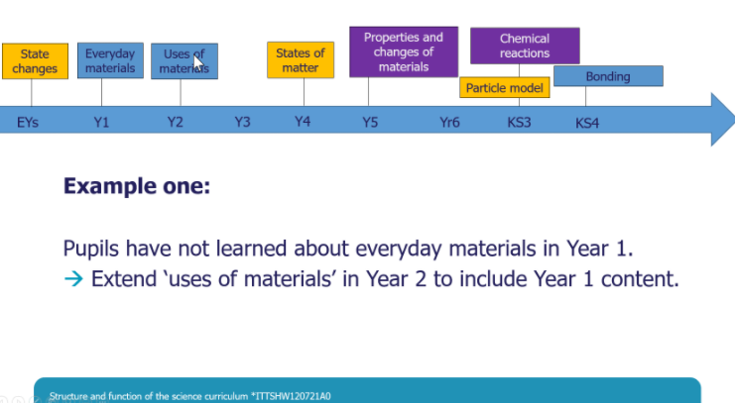 | Thinking about catch up  Progression model not broken, just delayed
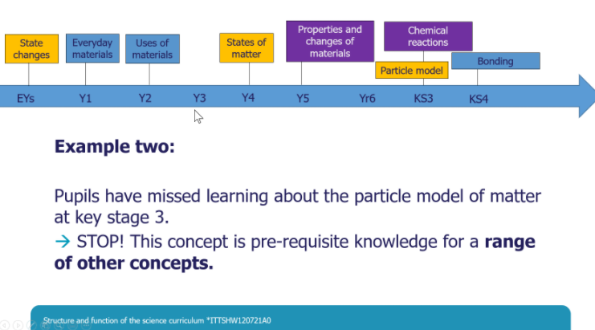
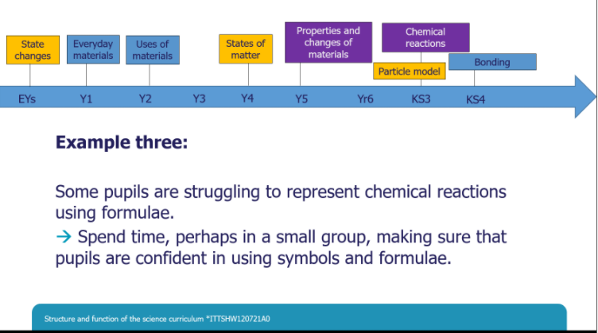 | Content taught, but variation. Need to provide specific support.
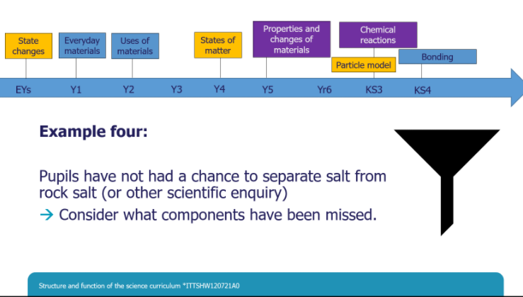 | Practical work disrupted by Covid
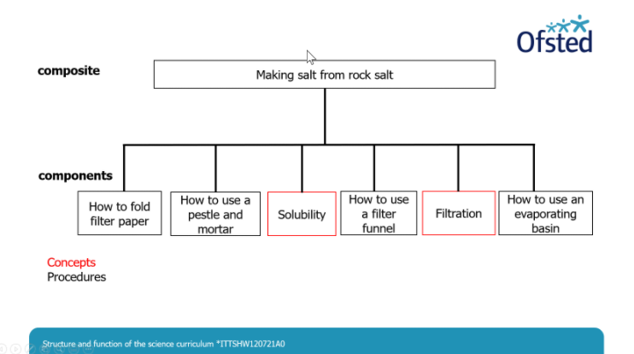
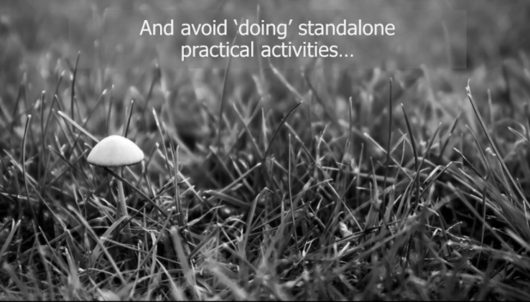 | Must be put in context of substantive contexts
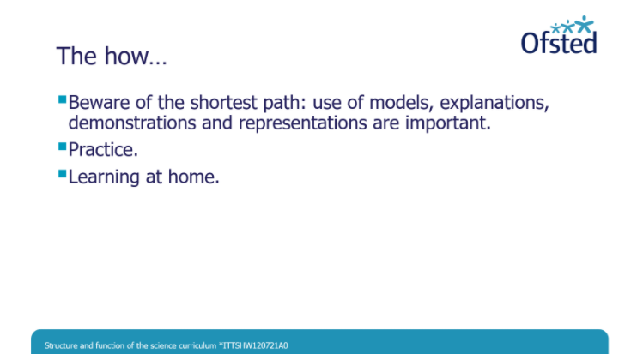 | Avoid temptation for children to simply memorise information.
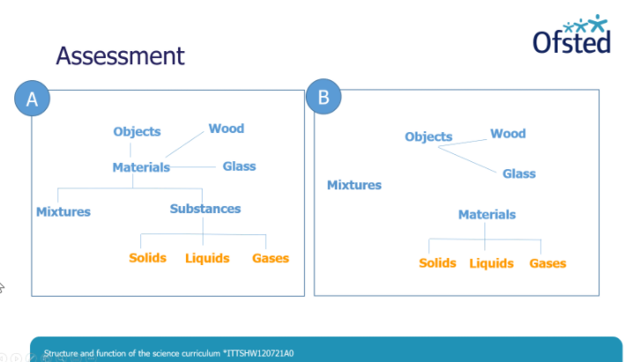 | Assessment in science  Primary role of assessment is to make the invisible (thinking), visible.
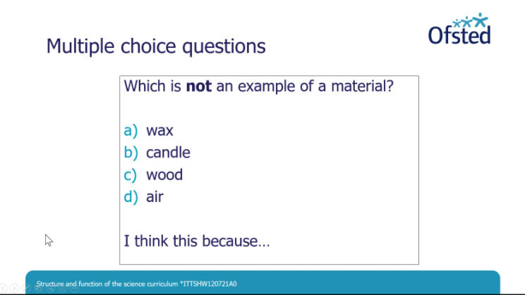 | Reasoning is key and provides most useful information to inform feedback
Q&A

Inspection method | Deep dives
Timeline for publication of other reports
18-21 months time for the others
Single subject lesson preferred or ‘creative’ approach?
No preference. Schools need autonomy but schools need to think about how developed over time. (think scope and coherence)

No time limits, but should be broad and deep with sufficient time spent to enable children to remember what is taught.

