Booking yourself onto a Health & Safety or First Aid course
- Log into Business World
- Go into Your employment; Your development; Course Catalogue
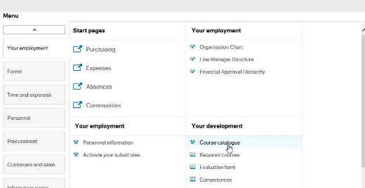
- Start typing the name of the course and a list will appear underneath; click on the correct course, press the tab button and click search
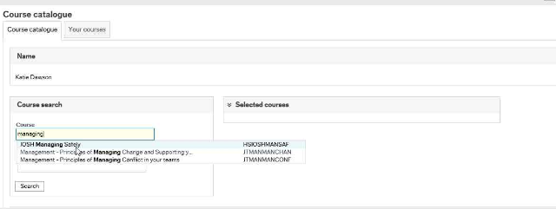
- A list of course dates will appear underneath; click the Sign up button to book onto the course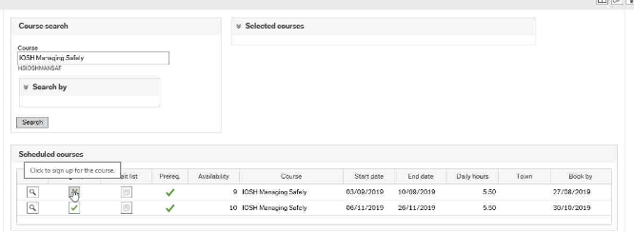
- If your training costs are being covered by another budget, please make sure you comment here with the correct cost code to charge
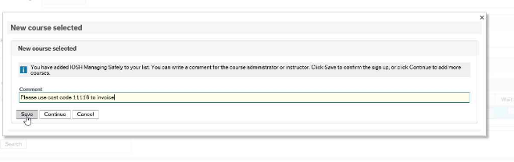
- Once you have saved the request, it will be sent to your line manager to approve and once this has been approved, you will be booked onto the course
