Booking an employee onto a Health & Safety or First Aid course as their line manager
- Log into Business World
- Go into Personnel; Course; Course Catalogue
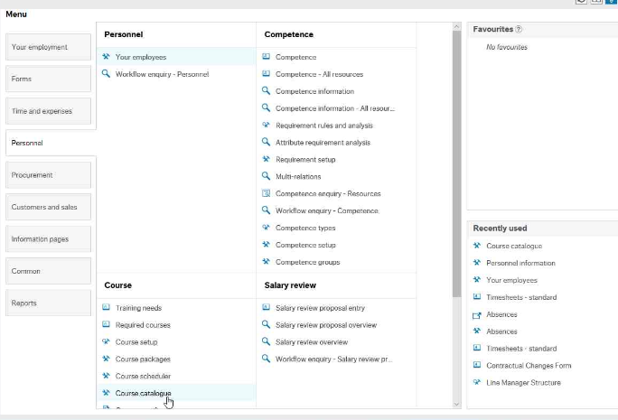
- Start typing the name of your employee or press space to get a list of all your employees; click on the correct name, press the tab button and click on the course field
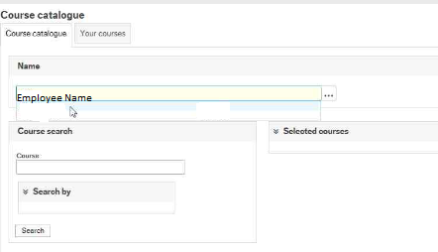

- Start typing the name of the course and a list will appear underneath; click on the correct course, press the tab button and click search

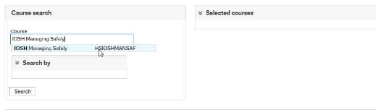

- A list of course dates will appear underneath; click the Sign up button to book your employee onto the course
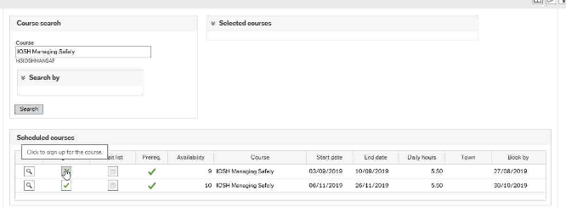
- If the training costs are being covered by another budget, please make sure you comment here with the correct cost code to charge
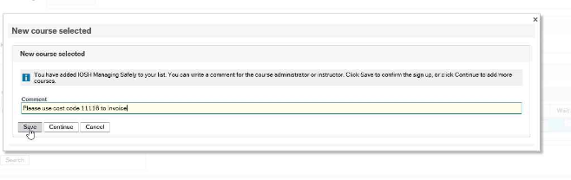
- Once you have saved the request, the employee will be notified, and their place will have been booked onto the course

