Place setting logo here | 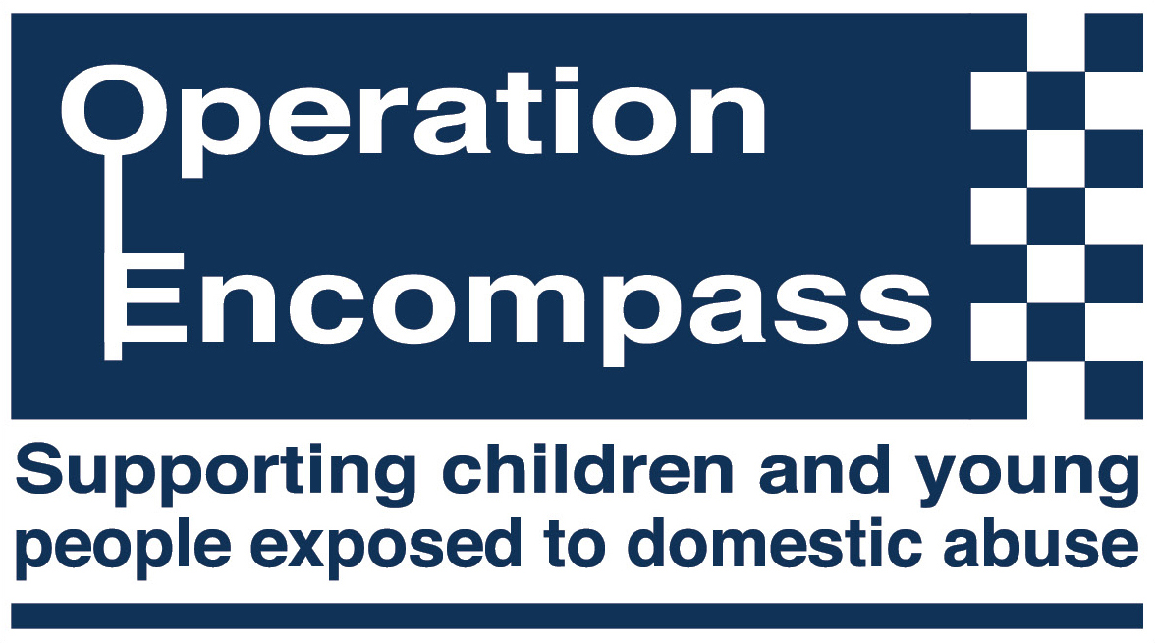
Enter date

Dear Parent/Carer

From September 2020, Early Years and Childcare settings in Shropshire have been given the opportunity to take part in a national project, which is being run locally in partnership with Shropshire Council and West Mercia Police.

Operation Encompass is a process whereby the police and the council will inform a member of staff if a child or young person has experienced any domestic abuse incident. This will be done prior to the start of the day. Information sharing between professional agencies allows setting staff to provide emotional and practical support to their pupils experiencing domestic abuse.

Domestic abuse can broadly be defined as ‘any incident or pattern of incidents of controlling, coercive or threatening behaviour; violence or abuse between those aged 16 or over who have been intimate partners or family members. This can include, but is not limited to, the following types of abuse – psychological, physical, sexual, financial and emotional.’

Operation Encompass ensures that a member of the setting staff, usually the Designated Safeguarding Lead, is given special training, to enable them to liaise with the police and council in receiving and using the information that has been shared, in confidence.

The sharing of details under Operation Encompass is permitted under Statutory Safeguarding Legislation and in respect of Early Years and Childcare settings under the Crime and Disorder Act (for the prevention of crime) and doing so without the child’s or parent’s consent is permissible under both pieces of legislation and the General Data Protection Regulation (GDPR).

We want to offer the best support possible to all our children and we believe, that where necessary, this will be beneficial in helping us to achieve that goal. Please make contact with me or the setting Designated Safeguarding Lead should you wish to discuss the content of this letter.

Attached is a list of local and national advice and support agencies who can help those who may be affected by domestic abuse.

Signed

Enter name

Enter position

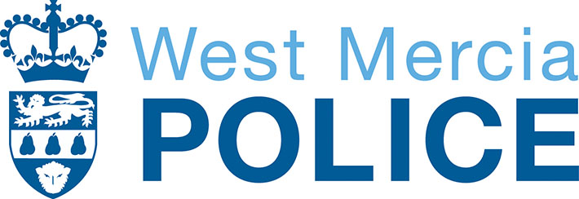 |  | 

Who to contact

West Mercia Police
101 (non-emergency)
999 (emergency)

West Mercia Women’s Aid
westmerciawomensaid.org
24 hour Help line
0800 783 1359
If you are worried or frightened by your partner or ex-partner, a family member or someone close to you, please ring our Helpline for support, advice and information about your options


Email: info@victimadviceline.org.uk
Web: www.victimadviceline.org.uk
Twitter: @WMerciaVAL
The Victim Advice Line is a free and confidential service for victims
and anyone who has been affected by crime and needs support.

Domestic Violence Disclosure Scheme (Claire’s Law)

This scheme aims to provide a formal mechanism for you to make inquiries about your partner if you are worried that they may have been abusive in the past, or about someone else’s partner on their behalf. If police checks show that the partner has a record of abusive behaviour, or there is other information to indicate that you may be at risk from your partner, the police will consider sharing this information with you or the person you are worried about. The scheme aims to help you to make a more informed decision on whether to continue a relationship and provides further help and support to assist you when making that choice. If you wish to make an application under the Scheme phone 101 (the non-emergency number for the police) and request to complete a Claire’s Law application.

Shropshire Domestic Abuse Service (SDAS)
www.shropsdas.org.uk
0300 303 1191
Shropshire Domestic Abuse Service (SDAS)
Offers refuge accommodation female and males
Outreach support service, face to face or telephone
Support groups across Shropshire
Referral Line 0300 303 1191

(Monday to Friday 9am to 5pm)

Shropshire First Point of Contact
Adults 0345 6789044
Children 0345 6789021

Front door for Adult Social Care, Adult Safeguarding, Compass (concerns and early help for children), Family Information, Under 18 and homeless.

The First Point of Contact or ‘FPOC Team’ are part of Shropshire Council’s Customer Service Centre. The team of advisors take calls and emails from members of the public looking for support and assistance for adults in Shropshire.

We also take calls from professionals and members of the public raising safeguarding concerns over the welfare of a child or young person in Shropshire or seeking professional advice at an early help level for children and their families.

Who to contact (cont’d)

National Stalking Helpline
0808 802 030
www.stalkinghelpline.org
The helpline provides guidance and information to anybody who is currently or has previously been affected by harassment or stalking. The Helpline can provide guidance on the UK law, reporting offences to the police, evidence gathering, and your personal safety.

Karma Nirvana
0800 5999 24
www.karmanirvana.org.uk
Providing support and advice around Forced Marriage (FM), Honour Based Abuse (HBA) and Female Genital Mutilation (FGM). Cultural acceptance does not mean accepting the unacceptable. One of our key principles is that we never talk to or engage with your family. Our commitment and loyalty is to you and as we understand the fears when family members become involved.

Paladin (National Stalking Advocacy Service)
020 3866 4107
www.paladinservice.co.uk
Paladin assists high risk victims of stalking throughout England and Wales.

ChildLine
0800 555 111
www.childline.org.uk
ChildLine is the UK’s free, confidential helpline dedicated to children and young people.

Men’s Advice Line
0808 801 0327 www.mensadviceline.org.uk
Confidential helpline for men experiencing domestic abuse.

National Rape Crisis Helpline
0808 802 9999 (Freephone)

National LGBT Domestic Abuse Helpline
0300 999 5428
help@galop.org.uk
Support for lesbian, gay, bisexual and transgender people experiencing domestic abuse.

Domestic Violence Disclosure Scheme (Claire’s Law)
This scheme aims to provide a formal mechanism for you to make inquiries about your partner if you are worried that they may have been abusive in the past, or about someone else’s partner on their behalf. If police checks show that the partner has a record of abusive behaviour, or there is other information to indicate that you may be at risk from your partner, the police will consider sharing this information with you or the person you are worried about. The scheme aims to help you to make a more informed decision on whether to continue a relationship and provides further help and support to assist you when making that choice. If you wish to make an application under the Scheme phone 101 (the non-emergency number for the police) and request to complete a Claire’s Law application.

