Risk Assessment

- Outline of activity or task to be assessed: Kick Stool & 2 Step + Platform Step Ladder  N.B. For further information and guidance please refer to the Risk Assessment Arrangements on the Intranet |  |  |  | Form No
Directorate:
Workplace/Team
Date of Assessment: |  | Date for Re-assessment
Name of Assessors: |  | Signature:
Manager/Headteacher: |  | Signature:

Hazard is something with the potential to cause harm. Risk is the likelihood of someone being hurt multiplied by the severity of the occurrence.  Level of risk = likelihood x severity  B. Risk Matrix – This section is used for guidance to complete section C. |  |  |  |  |  |  |  | PRIORITY OF ACTION  High 17 - 25 Unacceptable – Stop work or activity  until immediate improvements can  be made.  Medium 10 – 16 Tolerable but need to improve within  a reasonable timescale, e.g., 1-3  months depending on the situation.  Low 5 - 9 Adequate but look to improve by next review.  Very Low 1 – 4 Residual risk acceptable and no  further action will be required all the  time the control measures are  maintained.
5 x 5 RISK ASSESSMENT MATRIX
Increasing consequence or severity ➔ | 5 | 5 low | 10 med | 15 med | 20 high | 25 high
Increasing consequence or severity ➔ | 4 | 4 very low | 8 low | 12 med | 16 med | 20 high
Increasing consequence or severity ➔ | 3 | 3 very low | 6 low | 9 low | 12 med | 15 med
Increasing consequence or severity ➔ | 2 | 2 very low | 4 very low | 6 low | 8 low | 10 med
Increasing consequence or severity ➔ | 1 | 1 very low | 2 very low | 3 very low | 4 very low | 5 low
 |  | 1 | 2 | 3 | 4 | 5
 |  | Increasing likelihood or probability ➔
Score

5
4
3
2
1
Likelihood / Probability

Very likely / Almost certain
Likely
Fairly likely / Possible
Unlikely
Very unlikely
Description

Event is expected to occur in most circumstances
Event will probably occur in most circumstances
Event could occur at some time
Event is not likely to occur in normal circumstances
Event may occur only in exceptional circumstances
Score

5
4
3
2
1
Consequence/Severity

Catastrophic / Severe / Fatality
Major injury / ill health
Moderate (over 7 day injury)
Minor injury / ill health
Insignificant / no injury
Description

Death or permanent disability to one or more persons
Hospital admission required, eg, broken arm or leg
Medical treatment required, over 7 day injury
First aid is required
Injuries not requiring first aid treatment

C. Use information from section B to identify level of risk for each hazard

Note: Working at height should be avoided wherever possible.  The school uses kick stools and short step ladders for occasional use by staff for various tasks including accessing high level storage, putting up displays and cleaning.  Use of a Kick Stool or step ladder is ‘Working at Height’ The working at height regulations apply to work activities where there is a risk of falling and liable to cause personal injury.  Any working at height has the potential for an accident to occur causing lifelong injuries & disability. For this reason, additional controls are required to ensure the safety of the user. |  |  |  |  |  | 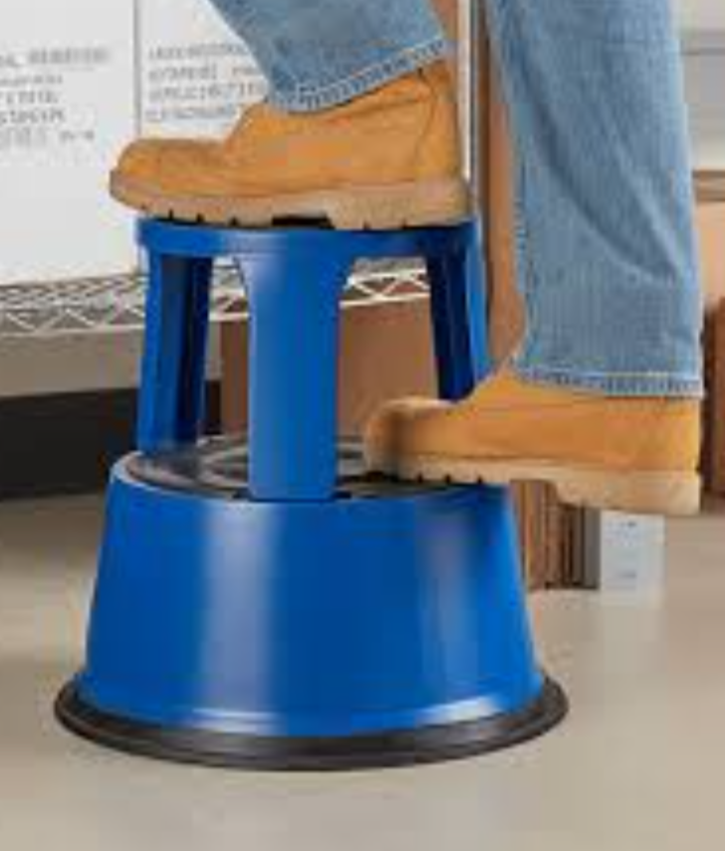 |  | 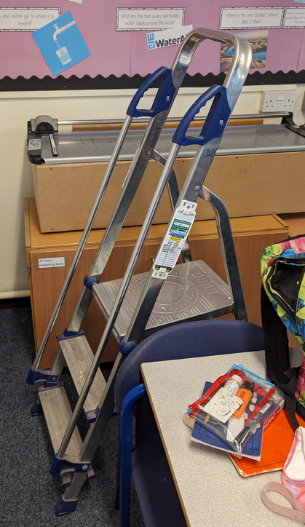
Part 1: Step Ladder
HAZARD |  | Who’s Affected | Existing Controls | Risk Level  Low/Med/High | What else is required |  | Risk Level  Low/Med/High | Action
 |  |  |  |  |  |  |  | Who | When
1 | Appropriate training & supervision; Lack of understanding the hazards and safety precautions required that could result in a fall from height. | User;  resulting in fall; potential strains, sprains and broken bones. | - Staff to complete basic ladder safety training, eLearning available on Leap into Learning (Approximately 10 – 15 mins)  - Staff to read/sign and follow the safety requirements of this RA, supported by annual ‘Toolbox’ talk by senior management.  - Senior management to provide appropriate supervision in the use of step ladders. | Low |  |  | Low
2 | Ladder being damaged or unsafe resulting in accident. | As above | - All ladders undergo regular safety inspection.  - Users to carry out ladder safety check before use.  - Staff to remove the faulty ladder from use and to inform their Line Manger. | Low | Consider ladder tag system for identifying ladder safety inspections. |  | Low
3 | Lone working;  - No persons to assist with loads.  - No person to assist following an accident. | As above | Infrequent users must not use the step ladder when Lone Working. | Low |  |  | Low
3 | Staff not wearing appropriate footwear or clothing resulting in loose footing and fall. | As above | - Staff must be wearing appropriate footwear flat and enclosed shoes (not tall heels or open slip-on shoes etc)  - Avoid wearing clothes that you could catch your heel when using the step ladder. | Low |  |  | Low
4 | Stability of ladder: | As above | Ensure the ladder is;  - Fully open  - Locked into position on a flat level surface. | Low |  |  | Low
5 | Lifting, carrying large items or heavy items. Requiring both hands to support the load. | User; Strains, sprains or muscle damage. | - Maximum weight of loads 3Kg approximately.  - 3 points of contact with the ladder to be maintained (including leaning on top cross rail).  - A second member of staff to pass items is present. | Low |  |  | Low
6 | Catering environments;  Slippery surfaces (wet shoes, oils/fats, cleaning products, spilt food) | Catering staff; resulting in fall; potential strains, sprains and broken bones. | - Spillages are cleaned up immediately.  - Warning signage available ‘wet floor’  - Catering staff to wear nonslip footwear.  - Floor area to be clean and dry. | Low |  |  | Low |  | .
D. Safe Systems of Work to be outlined below by using the information in Section C once completed:

Using the step ladder:

Do’s | Don’ts
It is important to visually check the stepladder for any signs of damage before use. If there are any obvious issues, report them to your manager immediately. | Don’t use a stepladder in an area where you could be knocked over. For example, behind a doorway or on a busy corridor.
Ensure the ladder is fully open & locked into position on a flat level surface. | Don’t twist your body to one side or stretch away from the ladder.
The stepladder must rest firmly on the floor without the risk of it slipping or moving during the task. | Don’t over-reach while on a stepladder. This will make your position on the stepladder unstable.
Ensure surrounding areas are free from clutter with clear access to the stepladder.
Always maintain at least 3 points of contact with the ladder (2 feet and a hand or 2 feet and your body).
Always face forwards while using the stepladder. Adjust the positioning of the ladder as needed.
Make sure your waist and hips stay within the vertical uprights and keep both feet on the steps.

Part 2: Kick Stool
1 | User not being familiar with the potential hazards of using a kick stool. | User resulting in fall; potential strains, sprains and broken bones. | Employees have received adequate information and instruction in working at height and the correct and safe use of the kick stool.  (Check for condition, wear appropriate clothing and footwear, follow safe manual handling practice) | Low |  |  | Low
2 | Kick stool is faulty or damaged. | As above | - Staff to check the safe condition and operation of the kick stool as detailed in Section D ‘Safe System of Work’ below before using.  - If damaged or faulty, do not use and report issue with your manager.  - Take out of use until repaired or replaced. | Low |  |  | Low
3 | Staff not wearing appropriate footwear or clothing. | As above | - Staff to wear appropriate footwear to ensure their stability when using a kick stool, flat and enclosed shoes. (not tall heels or open slip-on shoes etc)  - Avoid wearing clothes that you could catch your heel when using the kick stool. | Low |  |  | Low
4 | Manual Handling of heavy loads. | User; Strains, sprains or muscle damage. | - To follow safe manual handling practice and do not store large, awkward or heavy items at height or above head height. | Low |  |  | Low

If more hazards are identified please add more boxes

D. Safe Systems of Work to be outlined below by using the information in Section C once completed:

Before using a Kick Stool you must -

- Ensure the wheels are running freely
- Ensure there is no debris on the wheels or steps
- Check that it locks into position when you put weight on it
- Check the rubber on the bottom of the stool is not damaged and is stuck down securely
- Wear appropriate footwear to ensure your stability when using a kick stool
- Avoid wearing clothes that you could catch your heel on when using the kick stool

E. Circulation List
Please list people who have been informed of the assessment.

NAME | DESIGNATION | SIGNATURE | DATE

