DSE Workstation Checklist for Employees
Without Internet/Intranet Access.

Workstation location: |  | Computer No.
User:

Tel. Number:
Checklist completed by:
Assessment checked by:
Date of assessment:
Line Manager Name:

Line Manager Signature:

Any further action needed? | YES |  | NO
Follow up action completed on:

This checklist can be used as an aid to risk assessment and to help comply with the Health and Safety Display Screen Equipment (DSE) Regulations.

Work through the checklist, ticking either the ‘yes’ or ‘no’ column against each risk factor:
- ‘Yes’ answers require no further action.
- ‘No’ answers will require investigation and/or remedial action by the workstation assessor. They should record their decisions in the ‘Action to take’ column. Assessors should check later that actions have been taken and have resolved the problem.

Remember the checklist only covers the workstation and work environment. You also need to make sure that risks from other aspects of the work are avoided, for example by giving users health and safety training, and providing for breaks or changes of activity. Advice on this can be provided by the Occupational Health and Safety Team.

Risk Factors | Tick answer |  | Things to consider | Action to Take
1 Display Screens | Yes | No
Are the characters clear and readable?  ✓  Health and Safety  ✗  Health and Safety |  |  | Make sure the screen is clean and cleaning materials are made available.  Check that text and background colours work well together.
Is the text size comfortable to read? |  |  | Software settings may need adjusting to change text size.
Is the image stable, ie free of flicker and jitter? |  |  | Try using different screen colours to reduce flicker, e.g. darker background and lighter text.  If problems still exist, get the set-up checked, e.g. by the equipment supplier.
Is the screen’s specification suitable for its intended use? |  |  | For example, intensive graphic work or work requiring fine attention to small details may require large display screens.
Are the brightness and/or contrast adjustable? |  |  | Separate adjustment controls are not essential, provided the user can read the screen easily at all times.
Does the screen swivel and tilt?  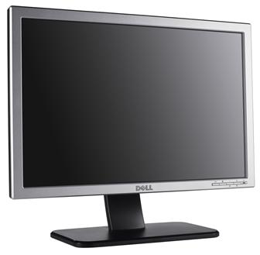 |  |  | Swivel and tilt need not be built in; you can add a swivel and tilt mechanism.  However, you may need to replace the screen if:  - swivel/tilt is absent or unsatisfactory;  - Work is intensive; and/or  - the user has problems getting the screen to a comfortable position.

Risk Factors | Tick answer |  | Things to consider | Action to Take
1 Display Screens (cont.) | Yes | No
Is the screen height adjustable?  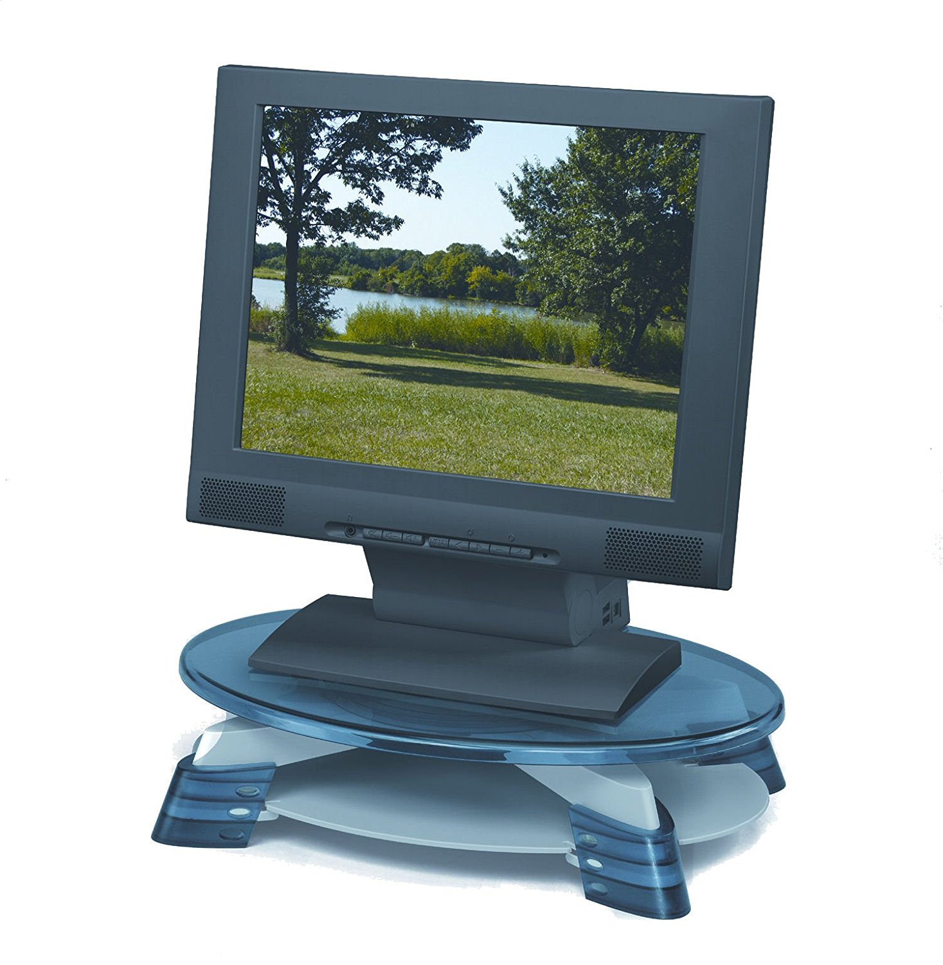  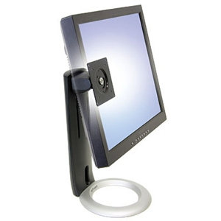 |  |  | The top of the screen should be at eye level. Use a monitor riser or adjustable monitor stand.
Is the screen free from glare and reflections?  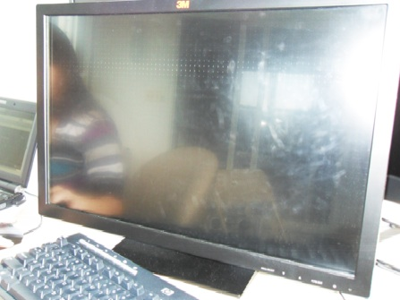  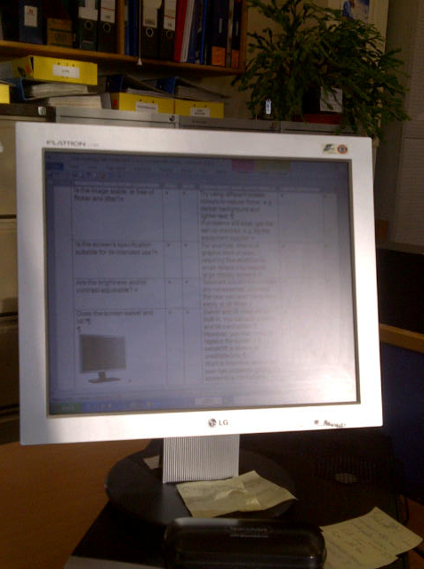  Are adjustable window coverings provided and in adequate condition? |  |  | Use a mirror placed in front of the screen to check where reflections are coming from.  You might need to move the screen or even the desk and/or shield the screen from the source of reflections.  Screens that use dark characters on a light background are less prone to glare and reflections.  Check that blinds work. Blinds with vertical slats can be more suitable than horizontal ones.  If these measures do not work, consider anti-glare screen filters as a last resort and seek specialist help.

Risk Factors | Tick answer |  | Things to consider | Action to Take
2 Keyboards | Yes | No
Is the keyboard separate from the screen? |  |  | This is a requirement, unless the task makes it impracticable (e.g. where there is a need to use a portable).
Does the keyboard tilt? |  |  | Tilt need not be built in.
Is it possible to find a comfortable keying position?    ✗  ✗  ✗ |  |  | Try pushing the display screen further back to create more room for the keyboard, hands and wrists.  Users of thick, raised keyboards may need a wrist rest.
Does the user have good keyboard technique? |  |  | Training can be used to prevent:  - hands bent up at wrist;  - hitting the keys too hard;  - overstretching the fingers.
Are the characters on the keys easily readable? |  |  | Keyboards should be kept clean. If characters still can’t be read, the keyboard may need modifying or replacing.  Use a keyboard with a matt finish to reduce glare and/or reflection.

Risk Factors | Tick answer |  | Things to consider | Action to Take
3 Mouse, trackball etc. | Yes | No
Is the device suitable for the tasks it is used for? |  |  | If the user is having problems, try a different device. The mouse and trackball are general-purpose devices suitable for many tasks, and available in a variety of shapes and sizes. Alternative devices such as touchscreens may be better for some tasks (but can be worse for others).
Is the device positioned close to the user?  ✗ |  |  | Most devices are best placed as close as possible, e.g. right beside the keyboard.  Training may be needed to:  - prevent arm overreaching;  - tell users not to leave their hand on the device when it is not being used;  - encourage a relaxed arm and straight wrist.
Is there support for the device user’s wrist and forearm? |  |  | Support can be gained from, for example, the desk surface or arm of a chair. If not, a separate supporting device may help.  The user should be able to find a comfortable working position with the device.
Does the device work smoothly at a speed that suits the user? |  |  | See if cleaning is required (e.g. of mouse ball and rollers).  Check the work surface is suitable. A mouse mat may be needed.
Can the user easily adjust software settings for speed and accuracy of pointer? |  |  | Users may need training in how to adjust device settings.

Risk Factors | Tick answer |  | Things to consider | Action to Take
4 Software | Yes | No
Is the software suitable for the task? |  |  | Software should help the user carry out the task, minimise stress and be user-friendly.  Check users have had appropriate training in using the software.  Software should respond quickly and clearly to user  input, with adequate feedback.

Risk Factors | Tick answer |  | Things to consider | Action to Take
5 Furniture | Yes | No
Is the work surface large enough for all the necessary equipment, papers etc?  ✗ |  |  | Create more room by moving printers, reference materials etc. elsewhere.  If necessary, consider providing new power and telecoms sockets, so equipment can be moved.  There should be some scope for flexible rearrangement.
Can the user comfortably reach all the equipment and papers they need to use? |  |  | Rearrange equipment, papers etc. to bring frequently used things within easy reach.  A document holder may be needed, positioned to minimise uncomfortable head and eye movements.
Are surfaces free from glare and reflection? |  |  | Consider mats or blotters to reduce reflections and glare.
Is the chair suitable?  Is the chair stable?  Does the chair have a working:  - seat back height and tilt adjustment?  - seat height adjustment?  - swivel mechanism?  - castors or glides? |  |  | The chair may need repairing or replacing if the user is uncomfortable or cannot use the adjustment mechanisms.

Risk Factors | Tick answer |  | Things to consider | Action to Take
5 Furniture (Cont’d) | Yes No
Is the chair adjusted correctly?  ✗  ✗ |  |  | The user should be able to carry out their work sitting comfortably.  Consider training the user in how to adopt suitable postures while working.  The arms of chairs can stop the user getting close enough to use the equipment comfortably.  Move any obstructions from under the desk.  For guidance on how to adjust your chair please see appendix 1
Is the small of the back supported by the chair’s backrest? |  |  | The user should have a straight back, supported by the chair, with relaxed shoulders.
Are forearms horizontal and eyes at roughly the same height as the top of the DSE? |  |  | Adjust the chair height to get the user’s arms in the right position, and then adjust the DSE height, if necessary.
Are feet flat on the floor, without too much pressure from the seat on the backs of the legs? |  |  | If not, a foot rest may be needed.

Risk Factors | Tick answer |  | Things to consider | Action to Take
6 Laptop (If applicable) | Yes No
Do you use any portable display screen equipment, (i.e. a laptop)?  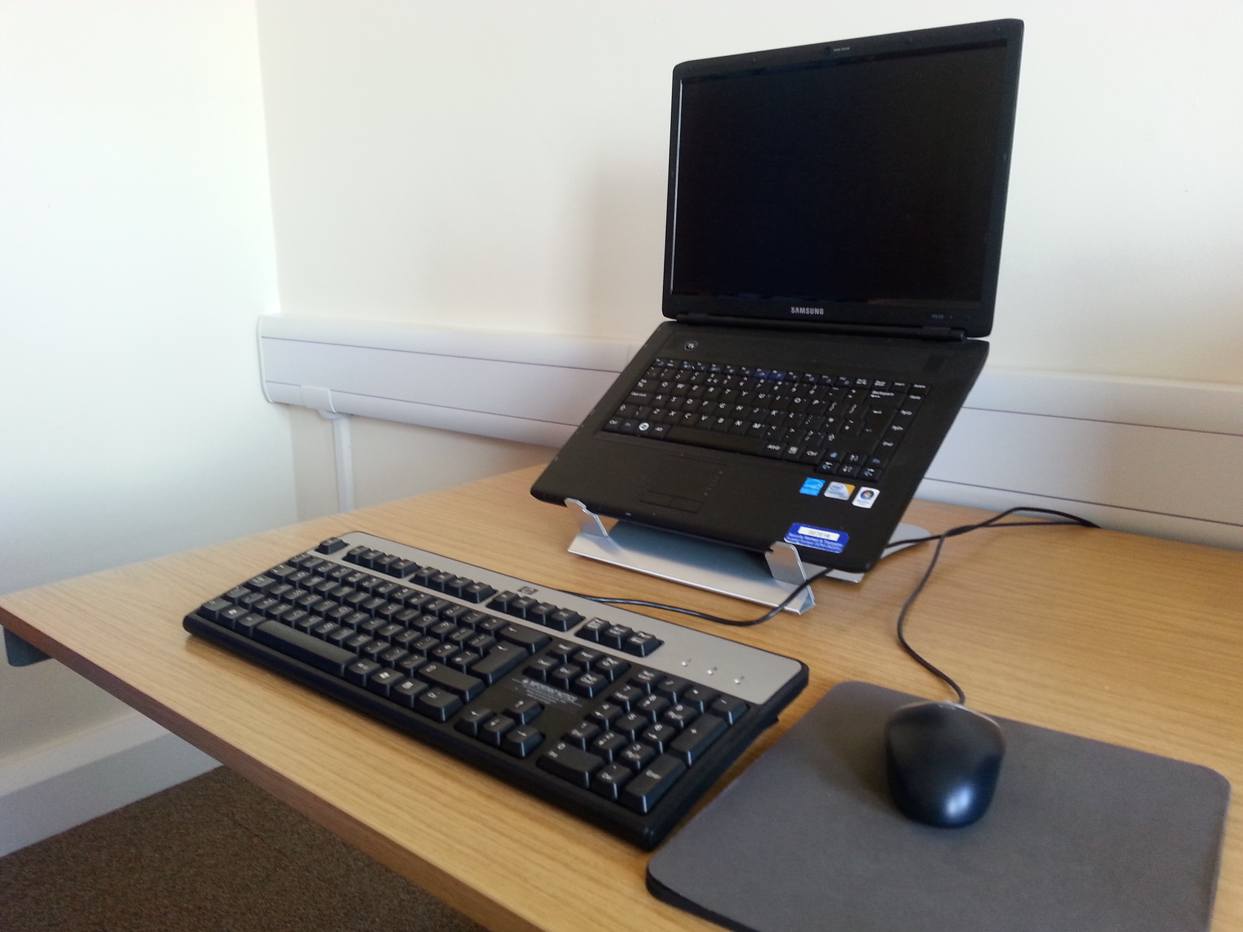  - A typical laptop docking station  ✗  - The above picture shows a set up that would not be acceptable for extended use. |  |  | Portable computers must not be used for prolonged periods at the employee’s main place of work without the use of a docking station or separate monitor, or laptop riser blocks - see picture (1)  Be aware that some design compromises inherent in portables can lead to postural or other problems (for example a bent neck, or headaches arising from the low, fixed position of the screen).  Because it is harder to find a good posture to use these devices, the risk to the user of discomfort and fatigue is increased and needs to be managed.  Portable DSE is only exempt from the regulations if it is not in prolonged use.
Do you use a laptop/notebook riser or separate screen?  - Laptop/notebook riser  - Separate screen  - Neither |  |  | Docking stations are a way to avoid many of the ergonomic disadvantages of using portable DSE (i.e. laptops) by allowing for example, the use of a full-sized screen, keyboard and mouse.
Do you use a separate keyboard? |  |  | When using the laptop keyboard, try not to drop your wrists onto the wrist rest. Instead, move your hands freely across the keyboard and keep your hands in line with your elbows.
Do you use a separate mouse or other pointing device?
Do you have any other concerns about using a laptop/notebook?

If you answered YES to the previous question, please describe:

Risk Factors | Tick answer |  | Things to consider | Action to Take
7 Sit/Stand desk (If applicable) | Yes No
An adjustable height sit-stand desk gives the option to sit or stand throughout the day. |  |  | Consider many of the above risk factors when setting up a sit/stand desk e.g. desk and screen height, keyboard, mouse, space to move.  The desk should be elevated to a height sufficient to ensure that the forearms remain horizontal when the hands are on keyboard and all other aspects of a neutral working posture are applied.
Sitting or standing too long |  |  | Consider an 20:20 regimen – or sitting (in a good posture) for 20 minutes, standing for 20 minutes. Going from sitting to standing and vice versa frequently throughout the day may help with risk factors associated with sitting, or indeed with standing for long periods

Risk Factors | Tick answer |  | Things to consider | Action to Take
8 Environment | Yes No
Is there enough room to change position and vary movement? |  |  | Space is needed to move, stretch and fidget.  Consider reorganising the office layout and check for obstructions.  Cables should be tidy and not a trip or snag hazard.
Is the lighting suitable, e.g. not too bright or too dim to work comfortably? |  |  | Users should be able to control light levels, e.g. by adjusting window blinds or light switches.  Consider shading or repositioning light sources or providing local lighting, e.g. desk lamps (but make sure lights don’t cause glare by reflecting off walls or other surfaces).
Does the air feel comfortable? |  |  | DSE and other equipment may dry the air.  Circulate fresh air if possible. Plants may help.  Consider a humidifier if discomfort is severe.
Are levels of heat comfortable? |  |  | Can heating be better controlled? More ventilation or air-conditioning may be required if there is a lot of electronic equipment in the room. Or, can users be moved away from the heat source?
Are levels of noise comfortable? |  |  | Consider moving sources of noise, e.g. printers, away from the user. If not, consider soundproofing.
9 Final questions to users
Ask if the checklist has covered all the problems they may have experienced whilst working with their DSE?
Ask if they have experienced any discomfort or other symptoms, which they attribute to working with their DSE?
Ask if the user has been advised of their entitlement to eye and eyesight testing?
Ask if the user takes regular breaks working away from DSE?
Write the details of any problems here:

Appendix 1

Office Chair Set-Up Guidelines

Chair tilt

Chair recline tilt
Allows the whole chair to tilt relative to the floor.
Ergonomic Chairs recline to reduce the pressure on discs and muscles, allowing you to relax and reduce the strain on your back.
There are two types of tilt; one that pivots from the central point under the seat, your feet will come off the floor as you recline. The other is a knee tilt where the pivot is closer behind the knees, foot lift is negligible and your back and head will descend more than a central pivot. This allows movement without losing support.
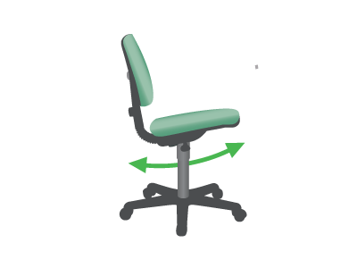

Seat angle tilt adjustment
Allows the seat to tilt forward to rotate the pelvis.
When you stand up your pelvis rotates forward. This posture produces the least amount of stress on muscles, tendons and discs whilst upright. It also pulls the chest out, increases lung capacity and facilitates breathing as well as improving the working of the heart and blood circulation. Furthermore, it allows you an open abdomen, which aids digestion.
When your pelvis is tilted forward your lumbar spine curves naturally and the rest of your spine follows.
This posture should be adopted when working upright or forward. The backward seat tilt can be used in conjunction with the backrest tilt to relax the spine and take some pressure off discs and muscles.
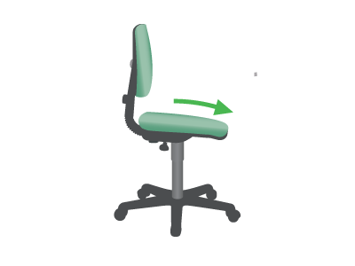

Seat

Height adjustable seat
Allows you to adjust the chair so that feet are firmly on the floor or footrest.
Also ensures that keyboard/work surface are at an appropriate height.
In a perfect world you should be able to achieve both without a footrest. A height adjustable desk may be part of this ideal solution.
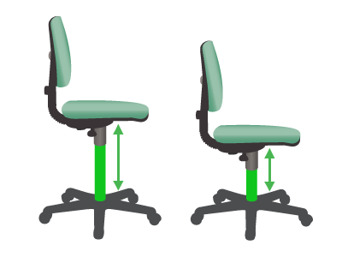

Seat depth adjustment
Allows you to adjust the seat depth by moving the seat or backrest in and out.
When seated you need to be fully supported by the backrest.
If you are short in the thigh you will need to reduce the seat depth so that you can reach the backrest and reduce pressure on the back of your thighs. Shorter people often perch on the front of the seat, getting no support from the backrest, compromising their natural posture and causing their muscles to overwork.
If you are long in the thigh, seat depth adjustment will allow you to support your thighs correctly.
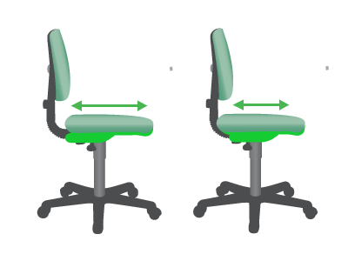

Backrest

Backrest angle adjustment
Changes the angle of the backrest relative to the seat.
Reclining the backrest whilst not working forward (keying or writing) allows the backrest to take some of the weight of your upper body. This in turn reduces the pressure on discs and muscles.
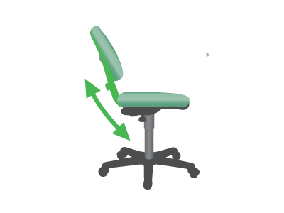

Armrests

Height adjustable armrests
Allows the vertical height of the armrests to be adjusted.
Supports the weight of your arms, removing the muscle work for shoulders and upper arms.
Armrests can be of particular benefit for support when keying or mousing. However, if they are not adjustable they can cause problems when armrests hit the edges of tables, causing users to key/mouse with a straight arm or perch on the front of the chair receiving no back support.
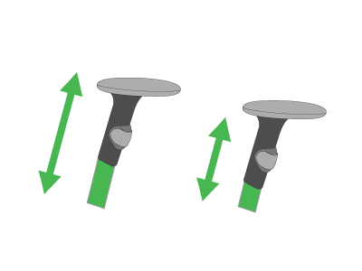

Width adjustable armrests
Allows you to position the armrest the correct distance from your body.
Armrests that are close to the body can help avoid splayed elbows, which in turn cause the wrists to bend to the side during activities such as keying.
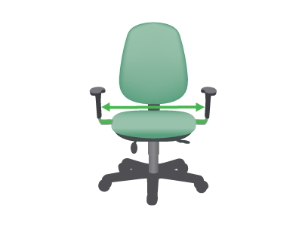

Padded armrests
Avoid uncomfortable pressure on the undersides of the forearms and elbows.
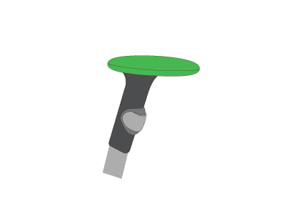

Lumbar

Lumbar support
Gentle curves in the backrest shape or inserts into the body of the backrest.
Lumbar support is intended to avoid flattening of the lumbar spine that can occur when seated and is used best in conjunction with a tilting seat.
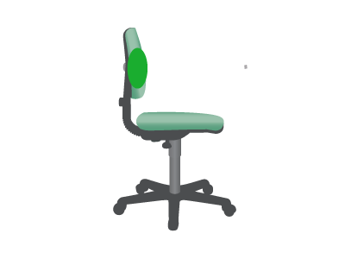

Lumbar pump depth adjustment
Allows the depth and sometimes the firmness of the lumbar support curve to be adjusted.
This best accommodates different preferences and body shapes.
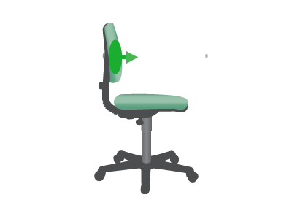

Lumbar height adjustment
Changes the height of the lumbar support area of the chair backrest.
This feature accommodates preferences by different workers regarding where the lumbar support curve contacts the back.
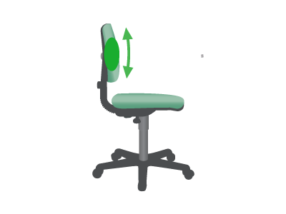

Headrest

Headrest height
Changes the height of the headrest to provide ergonomic support.
Particularly helpful for people with neck and shoulder problems, and they allow the muscles in this area to relax, thereby increasing the blood flow.
The ergonomic chair headrest is normally only used when slightly reclined.
